RaveWave is an Ecommerce store that sells products for those who go to raves, festivals, concerts and all EDM enthusiasts. RaveWave’s biggest challenge is simply getting more awareness and engagement with our target audience.
The beginning of the semester we started with 94 Instagram followers, 26 Twitter followers and 100 on Facebook. RaveWave at the beginning of the semester had no sales with about 10-15 visitors per day.
For RaveWave I decided to up our posting to 2-3 times a week per platform. I not only created content around Rave and Festivals but also curated some as well. For example, of creating content I would write a blog post on the site then post that to social media. I would then take articles from what was going on in the EDM community and push those to our platforms. Another form of posting I did was relate our posts to what’s going on in the world just as making a post about rave relate to valentine’s day. Those posts were the ones that got the most engagement.
Below is screen shots of RaveWave From early on in the smester
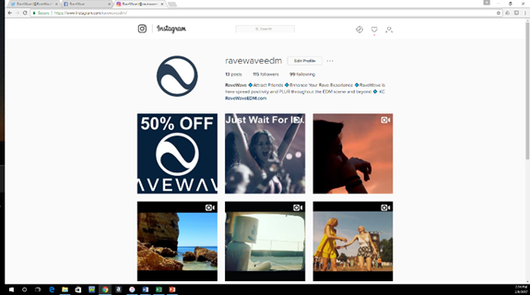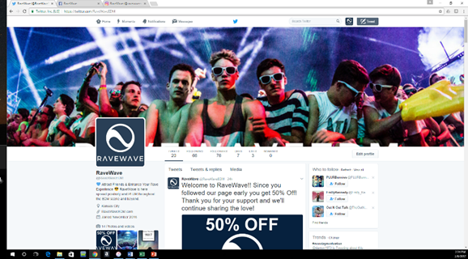

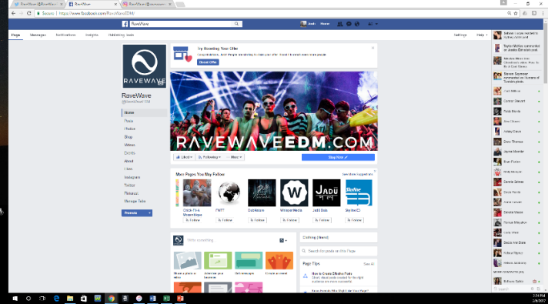
RaveWave Instagram now has 128 followers, Facebook has 190 and twitter has 77 and now has two sales with on average 15- 20 visitors a day.
I feel these results are completely dissatisfactory and I am very disappointed in myself. I have a lot of excuses going through my head as to why this is but I feel there is no need to mention those. The fact of the matter is I should have been more consistent, more focused and stayed course with my plan.
Moving forward

