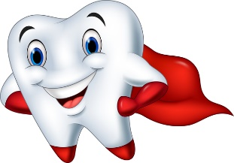

Preventive Strategies Paper
By. Abby Morrison

Biographical Sketch
Katie Conn was my preventative strategies patient. Katie showed signs of inflammation that I believed would heal after completed treatment. She presented with redness, edematous, localized blueness, and swollen tissue. As Mrs. Callihan would say, “Healthy tissue is resilient.” Inflammation is beneficial in beginning the host defense process. Without inflammation, wounds and infections would never heal and be a threat to the life of an individual.¹ It can also be disease-producing if not addressed.
Katie is a 24-year-old, female Caucasian. She graduated from Paola Learning Center with her GED. She continued her education at Fort Scott Community College, completing her pre-requisites for the nursing program. She postponed her education after having her first child. Katie is presently uncertain if she will continue her education. She is now a stay at home mom to her 3-year-old son and 5-month-old daughter and plans on homeschooling them in the future.
Learning about my patient’s history was effective in determining what factors played a role in her current oral health. Growing up Katie moved to multiple towns and experienced eight different schools. Changing schools so often created educational challenges and put her behind in school. In her childhood, she lacked consistency in all aspects of life, including dental care. Katie went to the dentist sporadically throughout her childhood. She was not taught to brush her teeth every day nor did she have supervision to enforce the task. As an adult, Katie does not have dental insurance and chooses to take care of her children’s health needs over her own.

Assessment
- Medical History
Overall, Katie’s systemic health was good. She presented with 70% loss of hearing in her right ear, an allergy to codeine, anemia, and healthy vitals. As a child, Katie had tubes placed in her ear multiple times and continued to have several ear infections, rupturing her eardrum. When she was 12-years-old a surgery was performed in attempt to correct her ruptured eardrum. In result, she lost 70% of her hearing in her right ear. I had to keep this in mind while communicating with her during treatment. Katie was diagnosed anemic as a teenager and was told she had an iron deficiency and could take an iron supplement to balance the deficiency. With anemia, the body does not produce enough healthy red blood cells to carry enough oxygen to the body’s tissue.² Red blood cells contain hemoglobin, which are important to successfully carry oxygen to your lungs and all parts of your body, and to carry carbon dioxide from other parts of your body to your lungs in order for the body to exhale.² Without enough iron, your body can’t produce enough hemoglobin for red blood cells.² The effects can leave you feeling tired and weak. Today, she no longer takes the iron supplements and believes she grew out of the diagnosis. According to the Mayo Clinic, anemia can be temporary or long term.² Katie described her reaction to codeine as hives all over her body and her intestinal tract shut downs. An alert to Eaglesoft was added. The biggest threat to Katie’s health is that she is a smoker and is uninterested in quitting. I added an alert for smoking because it’s a major contributing factor to periodontal disease. Katie said she is smoking a half pack of cigarettes a day, depending on her stress level. Dr. Hodes did not give a referral to a physician, because she was in good health and showed no signs or concerns that needed to be addressed.
- Dental History
The only complaint Katie expressed, was the “white stuff” on the lingual of her mandibular anterior teeth. I explained to her that she had calculus in that area and in multiple other places. I later showed her the intraoral photos to show the visible calculus. During her third appointment, after a quadrant of scaling, Katie had minor sensitivity on the lower left where treatment was completed. I applied fluoride varnish to address the sensitivity and recommended salt water rinses. At the next appointment, she said the sensitivity was significantly better. As I mentioned previously, she had dental treatment sporadically throughout her life. When she did have a cleaning and was recommended to have a filling, she followed through with treatment. There were a few years between each cleaning as a child. In 2012, Katie had orthodontic treatment. She wore braces for a year and successfully straightened her teeth and corrected her bite. As a child, she brushed her teeth once a day if she remembered and rarely flossed. She never had any horrible experiences at the dentist and expressed she always enjoyed getting her teeth cleaned. It had been 5 years since she had a dentist appointment before she came to our clinic. When I asked why it had been so long, she emphasized not having dental insurance and how expensive treatments are. She chooses to take care of her children’s health needs over her own. The older she gets the more attention she gives to her oral health at home. She currently brushes her teeth twice a day and flosses regularly. She was recommended to come back every 6 months as a child, and more recently by Dr. Hodes. In the past, she did not follow this because her parents did not take her. After seeing intraoral photos and explaining what happens if her gingivitis progressed to periodontitis, Katie realized how important it is to continue regular treatment. She was pleased to learn about other options for dental treatment for people without dental insurance.
- Oral Examination
During the extraoral exam, I found clicking in the temporomandibular joint upon opening. Katie showed no signs of clenching, enlarged masseter muscles, or concern for the clicking. She said occasionally her jaw pops but causes no pain. The next thing that stood out to me was Katie had a lip piercing on her lower right lip. An oral piercing is important, because the mouth contains millions of bacteria. Piercing the mucosa could potentially cause infection. It could also cause trauma if a patient were to bite on the piecing. It is important for patients to keep the area clean and free of bacteria. Katie also had a fissured tongue. Her tongue appeared cracked and scared. Katie said she had a tongue piercing for a short period of time. She removed the tongue piercing when she learned the damage it could cause to her teeth and mucosa. The next thing I noticed was on her hard palate. When palpating her hard palate, I could feel palatal tori. In most cases tori appears to be a bump of extra bone. Although it is very common for a patient to have tori, it is important to take into consideration when taking radiographs. Tori can be extremely sensitive to the patient and they are often unaware they have the tori. The next thing I noticed was Katie had no anterior or posterior pillars. She informed me that she had a tonsillectomy in the third grade. I also noticed bilateral linea alba on the buccal mucosa. Linea alba appears as white, horizontal lines along the buccal mucosa. It is often caused from cheek biting.
Katie’s periodontal status was generalized moderate gingivitis. When assessing her gingival conditions, I noticed generalized redness of the tissues. The mandibular incisors had the most redness where the calculus was most abundant. There was edematous and bulbousness as well, due to the body’s response to bacteria. Katie also had localized blueness on the linguals of number 24 and 25. The tissues appear red because vascular permeability and vasodilation increases the blood flow, and the blood vessels become engorged with blood.¹ The blueness of the tissues occurs from circulatory stagnation. The blood vessels become congested and the blood flow becomes slow moving.¹ This is a part of the body’s immune response to bacteria. The purpose of the immune system in periodontal disease is to defend the body against the bacteria present in plaque biofilm.¹ The body identifies foreign substances and sends specific cells and biochemical-mediators to counteract the invaders and is a very complex system that works to eliminate the harmful bacteria and tissue if infection is present.¹ Even if that means some healthy tissue is destroyed as the bacteria is fought by the immune system. Polymorphonuclear leukocytes (PMN’s), macrophages, B-cells, and T-cells are the most active cells with inflammation.¹ PMN’s are the first cells to the site of infection and from there a series of cells are brought to the site repeatedly until the infection is destroyed.¹ In order for the cells to get to the infection site, there must be increased blood flow to carry them there.¹ Vascular permeability accommodates the cells coming in. With vascular permeability there is also plasma leakage. The plasma leakage creates the edema and swelling seen in Katie’s tissues. There was minimal bleeding associated with her gingivitis. I was surprised to see her bleeding index was only 7%. As Katie is a smoker, the nicotine in her blood flow creates vasoconstriction. Vasoconstriction slows the blood flow; in result, there is a decrease in gingival crevicular fluid. The decrease in fluid explains the absence of bleeding during probing. The plaque index scores were under 50% for each appointment, indicating Katie was doing a relatively good job at brushing. Although it was not a high plaque index, there was still plaque on the teeth. As Mrs. Geisbauer says, “Plaque is like double-sided tape.” When plaque is present on the teeth it is attracting more plaque to build in the area, becoming more mature. The longer plaque sits on the teeth the more pathogenic it becomes. If she takes care of the plaque, gingivitis can be reversed.¹ Plaque can also be referred to as biofilm.
Katie had a significant amount of supragingival and subgingival calculus. Before calculus is formed there must be biofilm formation. Acquired pellicle forms to the tooth in one to two days.³ As mentioned previously, the acquired pellicle serves as a double-sided piece of tape. Although biofilm serves as a protective barrier to acids, it also serves as the initial site for bacteria to attach.³ Biofilm grows in stratified layers and begins to colonize. After four to fourteen days, a slime matrix is created. The slime matrix is adherent and facilitates further microbial adhesion.³ At this point, some of the bacteria is anaerobic, the teeth appear fuzzy, and inflammation is seen clinically. Once the bacteria become motile and crystal formation begins, the immune response also begins. If this process is not mechanically disrupted daily, calculus can begin to form. Mineralization occurs from saliva, gingival crevicular fluid, and inflammatory exudate.³ It is important to remove calculus to create a smooth surface on the tooth. A smooth surface facilitates the attachment and retention of biofilm. ³ After exploring, I found over half of Katie’s teeth had supragingival and subgingival calculus. My faculty and I decided that she had moderate supragingival deposits and heavy subgingival deposits. Her probing depths ranged 1-3 mm, with a few 4 mm depths. Katie also had no recession. Based off her probing depths and lack of recession, I could tell she had no attachment loss. Attachment loss indicates the lack of support around the tooth. Probing depths can change, because they are measured from the gingival margin to the base of the sulcus. The level of the gingival margin can change with the amount of inflammation.¹ Attachment loss is measured from the cementoenamel junction, which is a fixed point. Attachment loss is very important in determining gingivitis or periodontitis. Since Katie had no attachment loss and inflammation, I could tell she had gingivitis. My faculty and I decided that she had inflammation generalized two and periodontal case type one. These details, as well as the radiographic interpretation, aided in classifying Katie as generalized moderate gingivitis. Inflammation generalized two indicates redness, edema, and some bleeding on probing. Periodontal case type one indicates no attachment loss and inflammation.
- Radiographic Findings
My faculty and I decided to obtain a CMRS on Katie. Since she has not been to the dentist in
so many years we wanted access to her full mouth. A CMRS allowed us to access bone levels, check for caries, and check for abnormal pathologies. After looking over the radiographs, we found Katie had generalized healthy bone. I was pleased to see this after finding so much calculus. The bone level helps determine the periodontal case type. Loss of bone indicates a patient has active periodontitis or is maintaining their history of periodontitis. Once bone has been destroyed, it cannot come back. It was great to see her status remained gingivitis, so that it could be reversed before she lost bone. On the radiographs, you could see significant amounts of calculus interproximal. Detecting the calculus on the CMRS helped me confirm Katie was a heavy subgingival deposit class and to detect the areas when scaling. Dr. Hodes told Katie she was very lucky to make it this long without any caries or bone loss. He told her she should really work on her smoking habit. There were no significant findings, but Dr. Hodes wanted to watch #2. It appeared to have possible incipient decay, limited to the enamel of the tooth, and Dr. Hodes believed it may remineralize on its own after treatment and fluoride. Katie was also missing #1, 16, 17, and 32. The teeth known as the wisdom teeth, never developed for her. Most people have their wisdom teeth removed and Katie felt very lucky to have never gotten them.

Diagnosis-Patient Education Goals
- Human Deficits
I felt that Katie had seven out of eight human need deficits. When I asked Katie why it had been so long since she has been to the dentist she expressed concern for the cost and her lack of dental insurance. She only has insurance for her two kids and was afraid she would not be able to afford the cost for her own treatment. This creates a deficit in freedom from fear and stress. She believes it has been five years since she has had a dental exam. Not having an exam creates a deficit in responsibility for oral healthcare, protection from health risk, and biologically sound and functional dentition. When assessing her tissue health, Katie had generalized redness, bulbousness and edematous. The inflammation gives a human deficit in skin and mucous membrane integrity of the head and neck. After assessing her gingival conditions, I explained to Katie how her tissues were red and appeared swollen. I showed her the intraoral photos, including the lingual of the mandibular anteriors with visible supragingival calculus. She told me her teeth felt dirty where her tongue sits. Her original concern when she came was the “white stuff” on her teeth. She knew she had something going on but did not realize how much calculus was on her teeth or what it was. Being unaware of what the calculus was, or her gingival conditions creates a deficit in conceptualization and problem solving while the significant amount of calculus applies to biologically sound and functional dentition. She also showed concern for the appearance of calculus on her teeth creating a deficit in wholesome facial image. Katie smokes cigarettes and said she was uninterested in quitting at first. She uses cigarettes as a coping mechanism. When she is under a lot of stress she smokes more. Smoking is another reason for a deficit in freedom for fear and stress, but also for protection from health risk. Together we made changes and she became informed on how to maintain her oral health. I even struck her interest on quitting smoking.
- Preventive Strategy Goals
The first strategy was to remove the calculus. Although calculus is not the cause of periodontal disease, it does serve as a contributing factor. Calculus is rough and creates a place for biofilm adherence and removing biofilm also removes the body’s need for the inflammatory response. Which would reduce the bulbousness, redness, and edematous in the tissue. Since Katie had a heavy deposit classification, I chose to use the Cavitron. The Cavitron provides a water lavage, allowing the area to be seen better. In addition, the water helps break up the endotoxins in the cell wall. Endotoxins stimulate the immune response and trigger inflammation. To reduce the inflammation, it is important to break up the endotoxins. The bubbles produced during cavitation alter or destroy the bacteria on the cell walls. The mechanical action of the Cavitron vibrates, creating micro-fractures to break down the calculus. I used the standard tip to break down the large pieces of calculus and followed up with the thinsert. Katie did not have deep pockets but had tenacious calculus under the contacts of her teeth. In some areas, I used the slimline tips to finish the areas under the contacts. When I used the slimline tips, I was careful to reduce the power on my Cavitron, so that a tip would not break. After using the Cavitron, I followed with hand scaling. Specifically, I used the 204sd to remove any interproximal calculus that was still present. After removing the calculus, I followed with polishing. I used Clinpro prophy paste. Clinpro is unique because it starts out as coarse grit and turns to fine grit on its own. Polishing is a lot for patient benefit; however, it helps create the smooth glassy surface on the tooth. Keeping the tooth smooth helps prevent biofilm from adhering to the tooth. The last thing I did was apply 5% NaF fluoride varnish to the full mouth. Fluoride helps the teeth remineralize the enamel. It also helps protect the teeth from bacteria. Often clinicians refer to varnish serving as a vitamin for the tooth. I paid special attention to the occlusal of number 2 since Dr. Hodes was hoping the tooth would remineralize on its own.
- Patient Education Goals
After the initial appointment with Katie, I instantly knew four major goals for her oral health that I wanted to address with her: brushing frequency, flossing more often, understanding why it is important to see a dentist more frequently, and of course smoking cessation.
I found smoking cessation to be the biggest concern. Since Katie is my sister and I knew she did not want to be nagged about it, I chose to start with some simpler concepts and work into smoking cessation. First, I started with brushing frequency. It seemed the older Katie got the more brushing became routine to her. I encouraged her to keep doing that. I explained the importance of breaking up the biofilm to prevent the process of calculus forming.
I was very excited when we received our Oral-B electric toothbrushes from the representative. I showed my sister the day we got them and as usual was extremely excited for more teeth stuff and about how cool it was. After seeing how excited I was, Katie became very interested in getting an electric toothbrush. She had some questions and I let her test my toothbrush, with a new toothbrush head, at home for a week to see if she was interested. If this had been a patient that was not my sister I would have shown them the test drive toothbrush in the clinic. I took advantage of the family aspect and felt the best way to intrigue Katie was to allow her to use it personally. She did end up getting one for herself and I am excited to see how her homecare improves.
The second thing I addressed was flossing. I found that showing her the intraoral photos and radiographs struck her interest, so I showed Katie her radiographs and pointed out the visible pieces of calculus in the interproximal areas. Most of her deposits were between her contacts and my goal was to express how important it is she continues to floss to remove the biofilm from her teeth. I asked Katie to show me how she flosses her molar areas, hardest areas to reach, and she already had a good C-shaped technique. I encouraged her to continue with her current technique. Katie expressed she is bleeding during flossing and I explained to her that the bleeding is caused from the inflammation in her gums, if she continues flossing the bleeding will reduce.
The next thing I wanted to discuss was continuing her oral healthcare more frequently. To prevent periodontitis, it is very important to continue regular cleanings. At the end of the appointment I showed her the before and after intraoral photos. She was shocked to see the difference and said the lingual of the mandibular anteriors felt significantly cleaner. She also noticed she could see the small gap between her front teeth again. As I go through the program, I have noticed my sister becoming more interested and aware of her oral health needs. We talk regularly, and she hears about what I am learning often. I have enjoyed seeing her take into considerations the things I am teaching her and not only applying them to her own life, but to her family’s life too.
Lastly, I addressed smoking cessation. Smoking is one of the significant risk factors in periodontal disease. Smoking creates the vasoconstriction in the blood. The decrease in gingival crevicular fluid and bleeding indicates impaired gingival blood flow.¹ The PMN function, first responders in the immune response, is also impaired. This causes a delay in healing wounds due to inhibiting basic cellular functions non-smokers have. If a smoker gets periodontitis, their response to periodontal therapy may be slower.¹ The presence of nicotine can aid in the destruction of alveolar bone. There is an increased amount of prostaglandins, matrix metalloproteinases, and interleukins being released.¹ Since PMN function is rendered, the body doesn’t phagocytize the bacteria, leading to further damage.¹ I did not want to scare Katie away and send her running out of the clinic presenting the information this way. Instead I chose to show her how it was evident she was a smoker. I described how she was not bleeding very much for how much inflammation she had going on. I did describe to her how her blood flow had slowed down and was preventing her tissues from bleeding. I showed her the intraoral photo of the mandibular anterior lingual. On number 24 and 25 she had blueness caused from the lack of blood flow. When Katie came to her third appointment, she was excited to inform me she went from smoking one half a pack of cigarettes a day to four cigarettes a day. It was a good feeling to see that my approach at slowly giving her information about oral healthcare and the effects smoking can have was helping. I knew that Katie had an iPhone and enjoyed social media. I informed her about the quitSTART app for when she felt ready to start quitting. Katie expressed great interest in the app and downloaded it chairside. I have checked in with her since treatment was completed. She is currently still smoking. She expressed she is currently renovating her home, causing a lot of stress. She said she still has the app and has made it a goal to be done in a year. In the future, I hope to see she has accomplished quitting smoking.
Dental Hygiene Treatment Plan
The original treatment plan I created consisted of five appointments. The first appointment was to collect data, including a CMRS, intraoral photos, probe depths, and gingival conditions. It is important to collect initial information, so I could make a personalized treatment plan based on Katie’s specific needs. I wanted to show her the intraoral photos and radiographs, so she could understand why it was important to have treatment completed. The CMRS would also be used to discuss bone level, periapical findings, and possible caries with the dentist. I did not include patient education on her first appointment, because I thought I would not have enough time to gather all the information and show all my findings to her. I also took the intraoral photos for further patient education during and after treatment was completed. My rationale for scaling was, Katie presented with heavy subgingival calculus, moderate supragingival calculus, and generalized inflammation. It is important for the calculus to be removed to begin the healing process. Since Katie had heavy subgingival calculus and she was my first heavy patient, I broke each quadrant of scaling into a separate appointment. My initial treatment plan did not include local anesthesia because my patient believed she could tolerate treatment without. Before I began scaling, I completed a dentist exam. I wanted to complete the dentist exam prior to scaling to ensure Katie had nothing that needed immediate attention or anything that could cause discomfort during treatment.
Her second appointment was the dentist exam, lower left quadrant, and patient education. At this appointment, I planned to discuss the radiographic interpretation with Katie and the dentist’s findings. I chose to begin with the lower left quadrant due to the amount of supragingival calculus in the area.
Her third appointment would begin with a post tissue assessment. Reviewing how the tissue healed from the previous appointment and making modifications if necessary. During this appointment, I planned to focus patient education on plaque and inflammation. I chose these topics to check how Katie’s MPI score was changing. Also, to continue educating her on how plaque harbors bacteria and inflammation is a sign of disease. I chose the lower right quadrant to finish the areas with an abundant amount of supragingival calculus. At this appointment. I also planned to take intraoral photos. I wanted to take more intraoral photos to show my patient the progress we were making and the changes in the tissue.
The fourth appointment would begin with another post tissue assessment of the lower right side. I wanted to focus patient education on how her gums were healing and showing her the progress treatment was creating. I would begin the upper right quadrant to continue progress towards completion of calculus removal. The last appointment would begin with a post tissue assessment of the upper right. I chose disease progression and homecare for my patient education topics. My rationale for my topics was that it was her last appointment and I wanted to be sure she knew how to maintain her homecare and understood how the gingivitis progressed throughout the time she did not go to the dentist. I planned to finish the upper left quadrant. I also planned to polish her teeth. I used polish only, because I had completed scaling by individual quadrants. When polishing was complete, I planned to take intraoral photos. I wanted intraoral photos for the after-treatment progress. Once, I took intraoral photos I would apply varnish to help remineralize the enamel.
Once I developed the treatment plan, I went over it with Katie. I explained to her that we could make changes if she felt she needed local anesthesia. I emphasized local anesthesia is commonly used for an extensive treatment like hers but was entirely up to her. Katie had confidence in the plan and signed consent without hesitation. Looking back at my first heavy treatment plan there is a lot I would change. Throughout treatment many changes were made. Described below are the decisions I made throughout the course of treatment.
Implementation
I felt the best way to monitor progress throughout treatment was by intraoral pictures. Katie benefited from having a visual image of what I was spending my time doing. She was always interested in seeing the progress as we went along. As the mandibular teeth were finished, she was amazed at how different it felt. Before each appointment I thoroughly reviewed my notes and created sticky notes of everything I wanted to accomplish at that appointment. The main thing I noticed is a lack of detail in my T&P notes. For example, my first appointment I indicated Katie had no chief complaint. While nothing was causing her pain, she was concerned about the calculus, “white stuff” as she called it, on the lingual of her mandibular anterior teeth. As a beginning clinician, I thought if it was not pain related I was not supposed to write or document it. Another example was when Katie experienced sensitivity I did not document the sensitivity she experienced. I am learning now that the more detail the better. It is a good self-refection to look back on previous notes and see where you can do better.
I made a few changes to my treatment plan throughout. The first thing I changed was local anesthesia. Katie lasted approximately two minutes without being numb. During the third appointment, she said she had quite a bit of sensitivity after the first quadrant was completed. In attempt to aid the sensitivity, I applied fluoride varnish upon completing the next quadrant. We also recommended she swish with salt water. At the next appointment, Katie said the salt water helped with sensitivity. I also learned when making the treatment plan it is important to plan out what order you scale each quadrant. I planned each quadrant for an individual appointment, but some appointments I had time to start the next quadrant. It is important that you do not numb each side of the mandibular arch at the same time, because it becomes hard for the patient to control their tongue or patients may find it challenging to breathe. In the future I will make my treatment plan so that the mandibular arches could not fall on the same appointment.
My preventative strategies goals remained the same throughout treatment, but I had the most changes to my patient education topics. My first appointment I did not plan patient education. At the appointment we discussed her radiographs. I showed Katie the interproximal calculus and I also showed her the intraoral photos. We discussed her gingival conditions including redness, edematous, and bulbousness. I showed her the blue interdental papilla between number 24 and 25. The second appointment, I planned on discussing radiographic findings. Since that fit better at the first appointment, I continued with plaque indices the second appointment. The third appointment I planned plaque and inflammation. Katie had shown an interest in an electric toothbrush, so I used that as an alternative to explain how it could help her homecare. The fourth appointment, Katie had an increase in her MPI score and I chose to focus patient education on plaque again. I wanted to stress the importance of plaque control to prevent calculus formation in the future. The fifth appointment I spent focusing on smoking cessation. I knew Katie was stubborn, but I also thought if I slid a few recommendations to strike her interest she may reconsider. Throughout treatment I brought up the concerns with smoking. As Katie is my sister, I knew not to be overly aggressive about it or she would tone out everything I was saying. I felt I was successful in striking her interest and by the last appointment Katie did say she was interested and looked forward to using the quitSTART app when the time came. Overall, Katie had great outcomes. She had decent homecare before treatment, but I think adding the knowledge to why it is essential in maintaining her oral health motivated her to keep improving.
Using the intraoral photos caught her attention when explaining plaque and calculus formation. I showed her the areas she was unable to see on her own, including the lingual of the mandibular anteriors. At first Katie was disgusted with the amount of calculus on her teeth. After explaining how it could be prevented, she was surprised brushing and flossing regularly could prevent a significant amount of the calculus formation. I showed her intraoral photos in the middle of treatment and there was visible evidence of tissue healing on the area that had been scaled. Her redness, edematous, and bulbousness all decreased. After each quadrant Katie began to go from moderate gingivitis to slight gingivitis by the end of treatment. Katie also learned clinics, such as Johnson County Community College Dental Hygiene Clinic, existed. As I mentioned previously, she avoided the dentist mainly because of finances and her lack of insurance. A consistent visit to a hygienist will do miraculous things for her oral health.

Maintenance
For Katie’s periodontal maintenance interval, Dr. Hodes recommended every six months. Katie presented with moderate gingivitis her first appointment. By her last appointment there were significant changes in her tissues and she left the clinic having slight gingivitis. Since she was showing signs of healing, we felt six months would be the best interval to suit her oral health needs. Katie did not have any significant findings during the dental exam. For that reason a referral was not given at this time.
I felt my TSR form could have provided more detail in the comment section. I indicated Katie began treatment with moderate gingivitis and left with slight gingivitis and I properly checked all the services provided. Besides the basic treatment I did not provide many comments aside from leaving with slight gingivitis. If I could change the TSR form, I would add comments pertaining to flossing often, the electric toothbrush, smoking cessation, and the importance to continue with frequent cleanings. I would include an encouraging message pertaining to her improvement in such a short period of time and looking forward to seeing her progress in the future.
Evaluation
Overall, I felt my patient was compliant with homecare. In the beginning she knew minimal information about how bacteria effects your mouth and left knowing how she has gingivitis, how it can progress, an app to help quit smoking, and preventative knowledge. In five years, I believe Katie’s oral health will be maintained. She has an electric toothbrush, general knowledge to maintain her oral health, and options for oral healthcare for people without insurance. I believe she will continue to get her teeth cleaned more regularly given that information. As she is my sister, I am not convinced it will be every six months. She tends to be forgetful, but I do believe she will go yearly and not take five years to go again. She made it clear that she does not want her teeth to have permanent damage.
I felt that my initial and re-assessment data were accurate. My inflammation, periodontal case type, and radiographic interpretation corelated with my diagnosis of generalized moderate gingivitis. I do believe that could have been an educated guess at the time. Looking back now, I have a significantly better understanding of the periodontium. I saw Katie at my third appointment and at this time distinguishing bulbous tissue was a challenge.
I do not think my documentation was inaccurate, but it lacked entirely too much detail. I wrote the bare minimum and I am so thankful I looked back at these documentations. I learned a lot by writing this paper and self-evaluating my own work. I learn more every week and find myself saying, “I wish I would have known that with this patient.” If I did this again I would change my documentation and be more informative with my patient education. I would keep in mind my patient education topics need to reflect my preventative strategies goals. From my first appointment with Katie to my last appointment, I was a much stronger clinician. I lacked confidence, still do, but it grew more and more with each appointment. Some of the most important things I learned were the Cavitron and what tips to use, distinguishing calculus, learning what to educate my patient on, and most importantly trusting the process and watching myself grow every week. I did all three skill strengthening sessions with Katie. In each session I took away how to adapt my instruments better, which tips to use, and to more effectively and efficiently detect calculus. I could say I would do the whole treatment over again because I felt I knew nothing then, but without doing this treatment I would not know what I do now. I have learned this semester that clinic is fun and that I am going to make mistakes. Some days I may spray water all over my patients face and that it is okay to laugh about it. Each day I take a way something new. Next semester, I am sure I will be able to say I knew nothing second semester.
Resources
Gehrig, Jill S., and Donald E. Willmann. Foundations of Periodontics for the Dental Hygienist. Fourth ed. Philadelphia: Wolters Kluwer, 2016. Print.

Anemia [Internet]. Mayo Clinic. Mayo Foundation for Medical Education and Research; 2017 [cited 2018Apr2]. Available from: https://www.mayoclinic.org/diseases-conditions/anemia/symptoms-causes/syc-20351360

Darby, Michele L., and Margaret M. Walsh. Dental Hygiene Theory and Practice. Fourth ed. St. Louis: Saunders, and imprint of Elsevier Inc. Print.

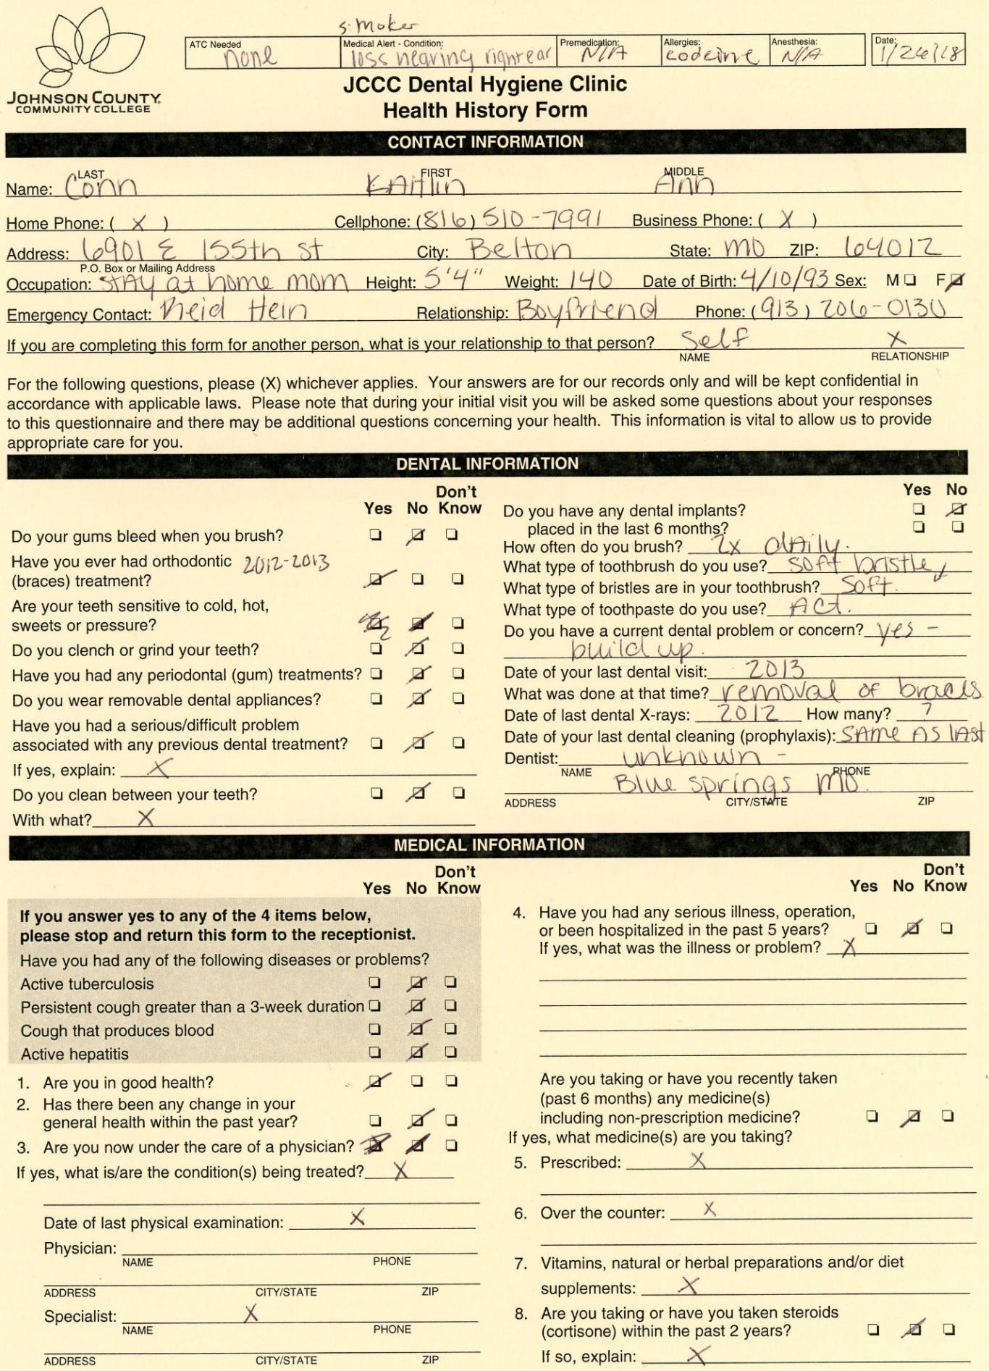
Documentation
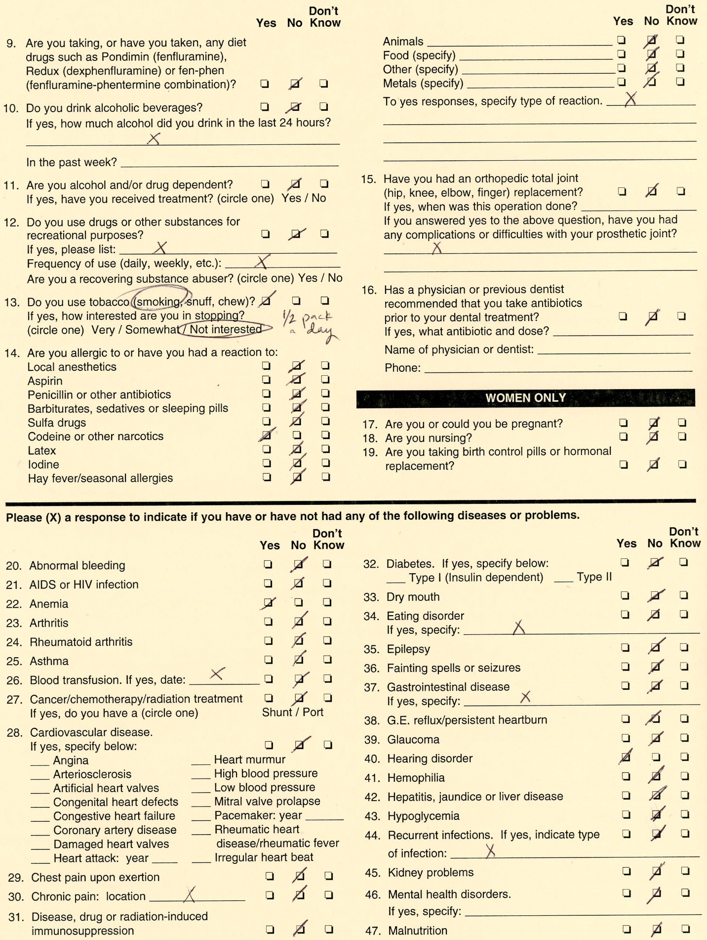
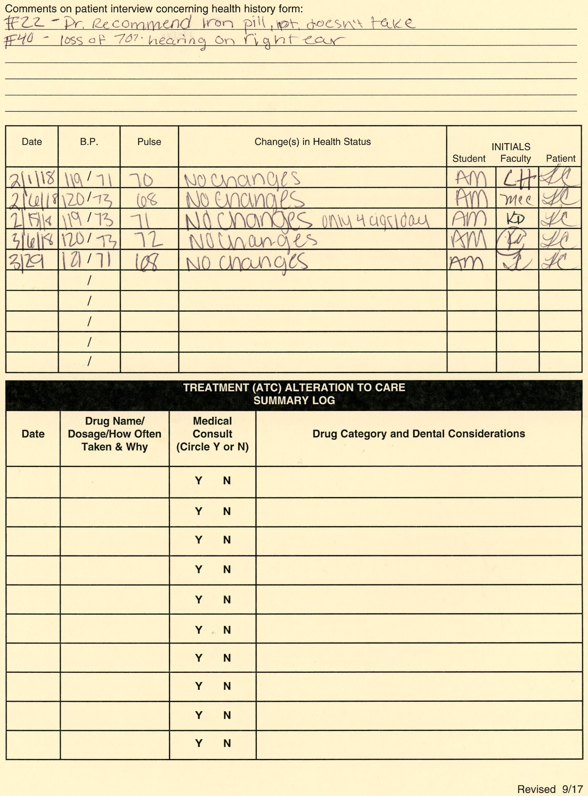

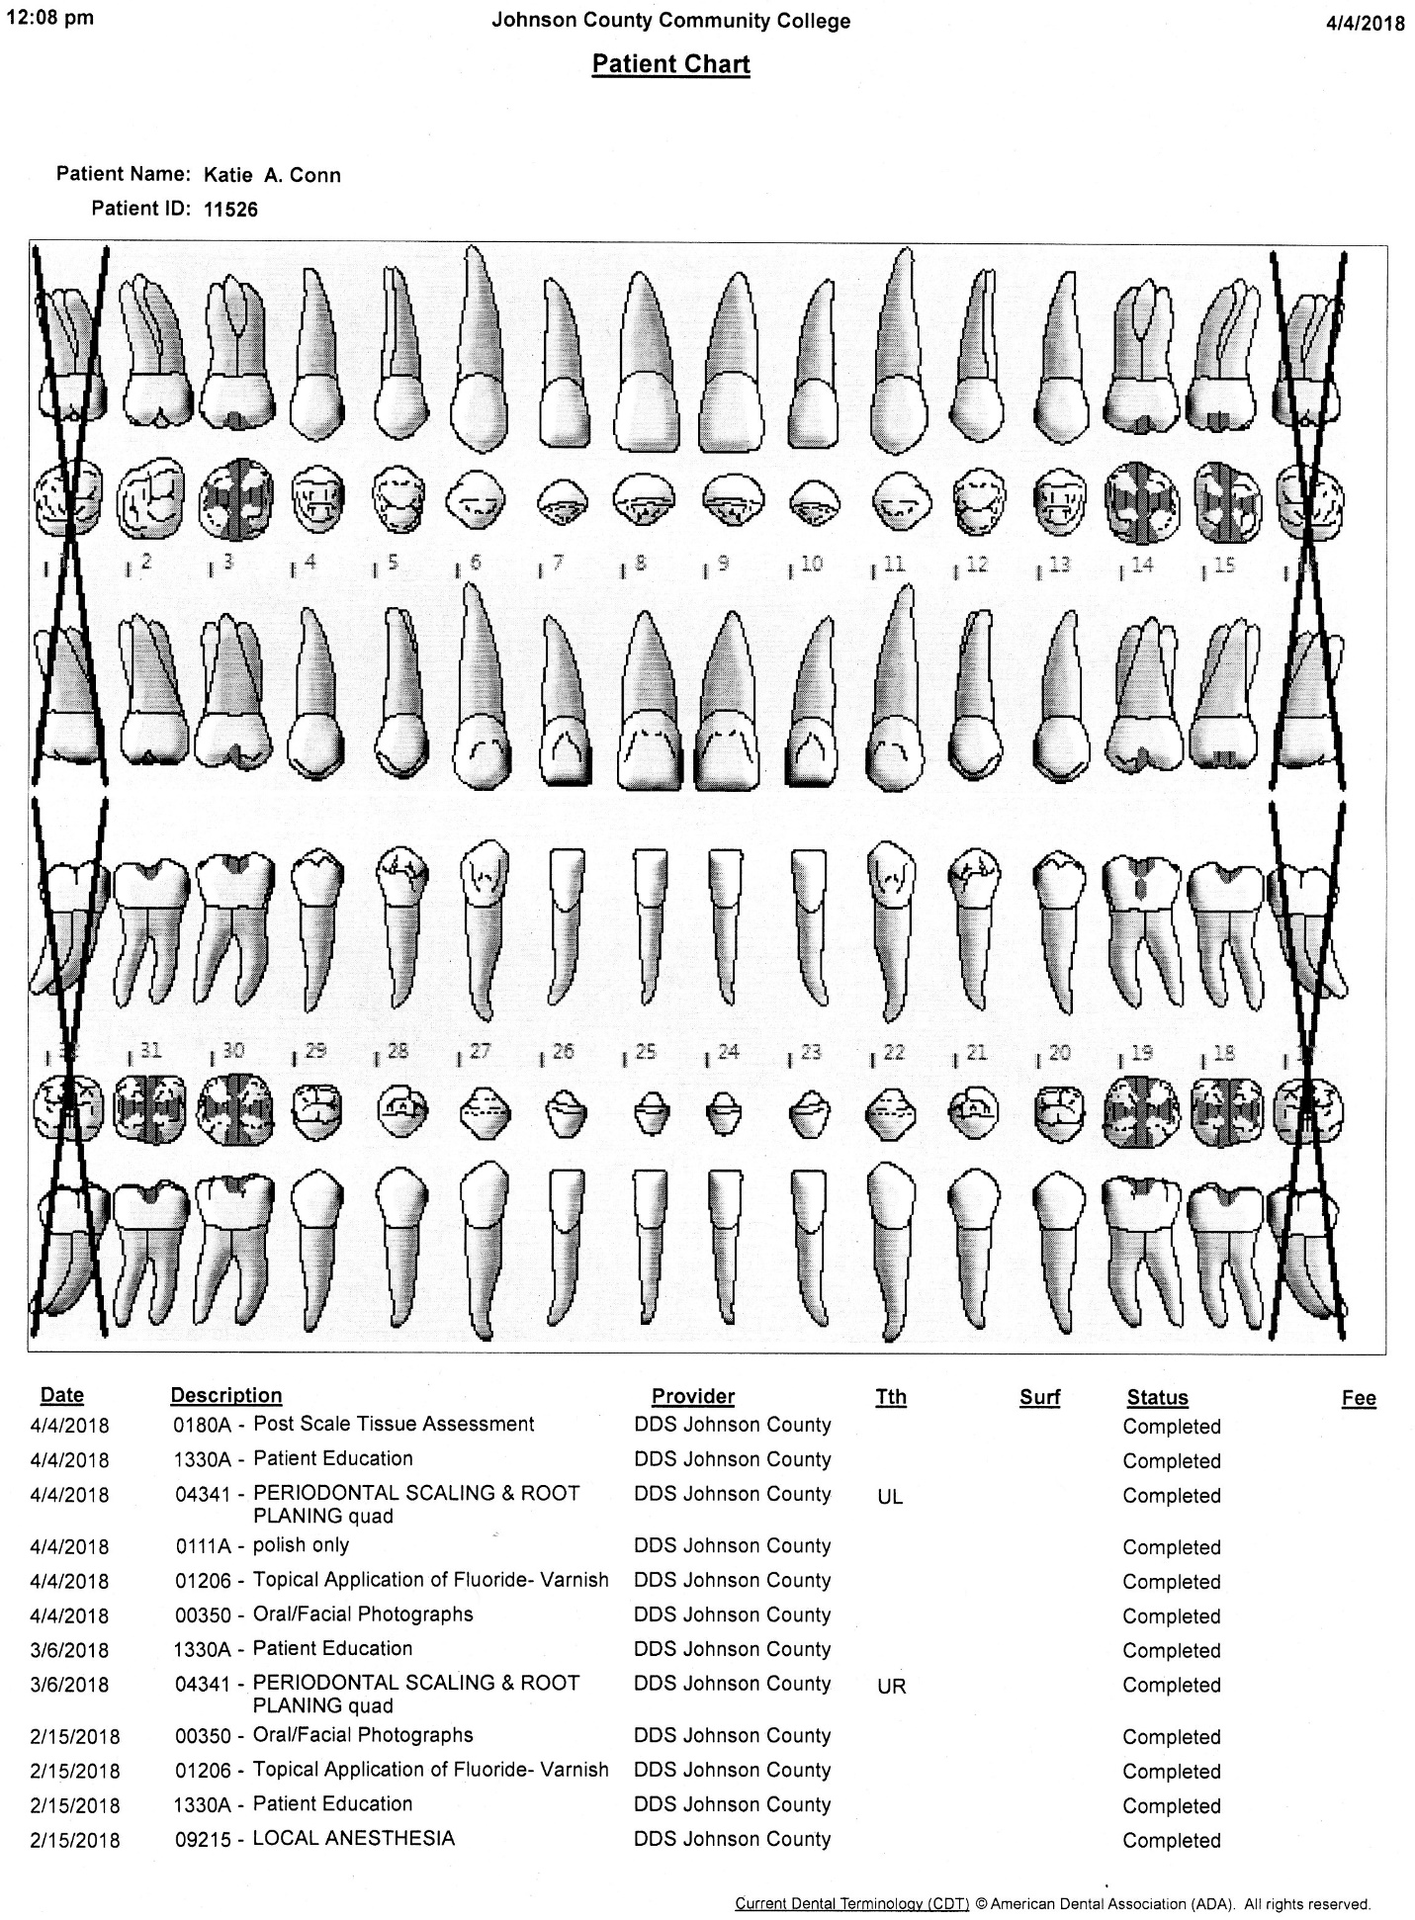
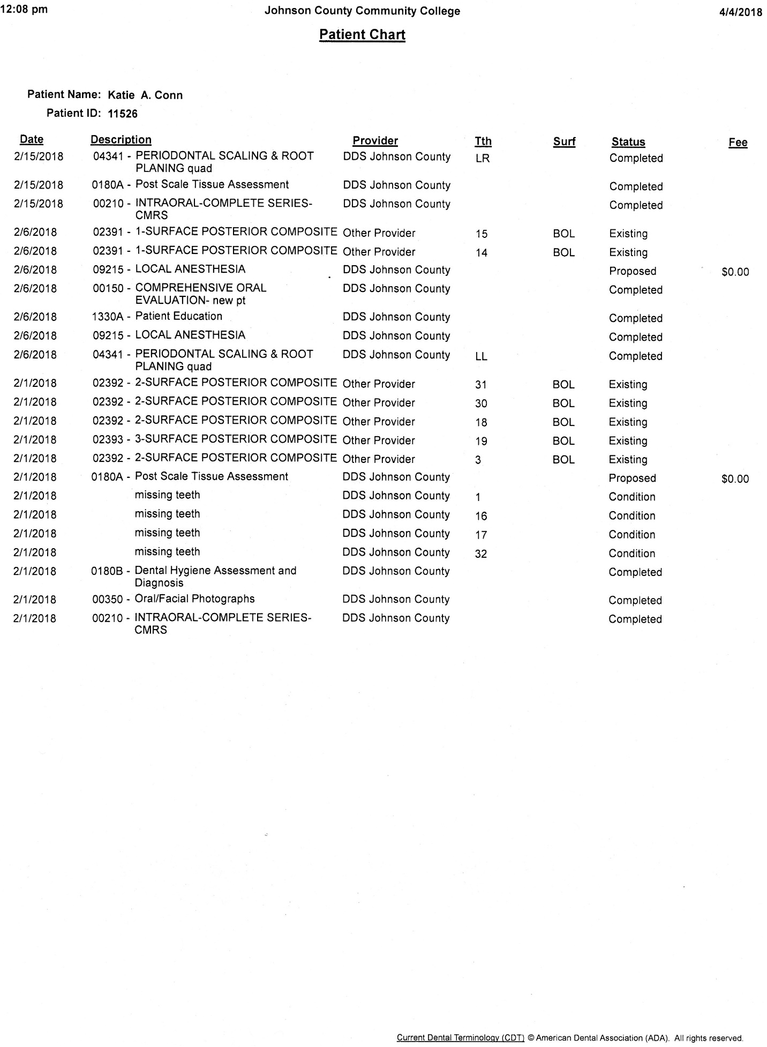
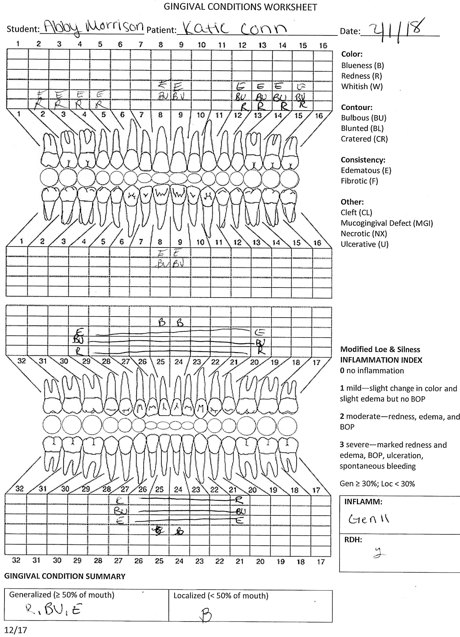

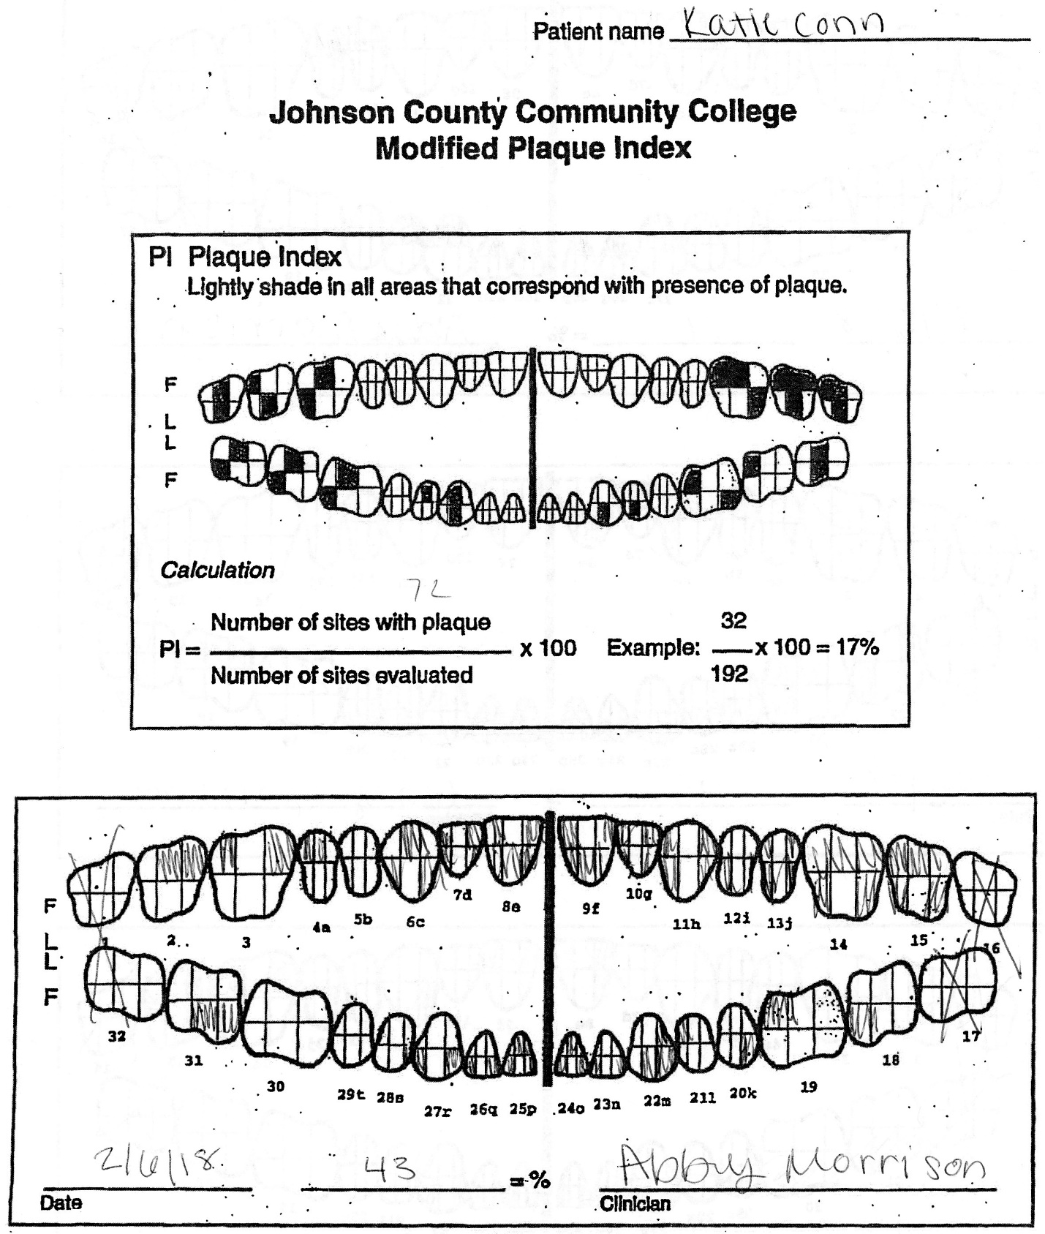

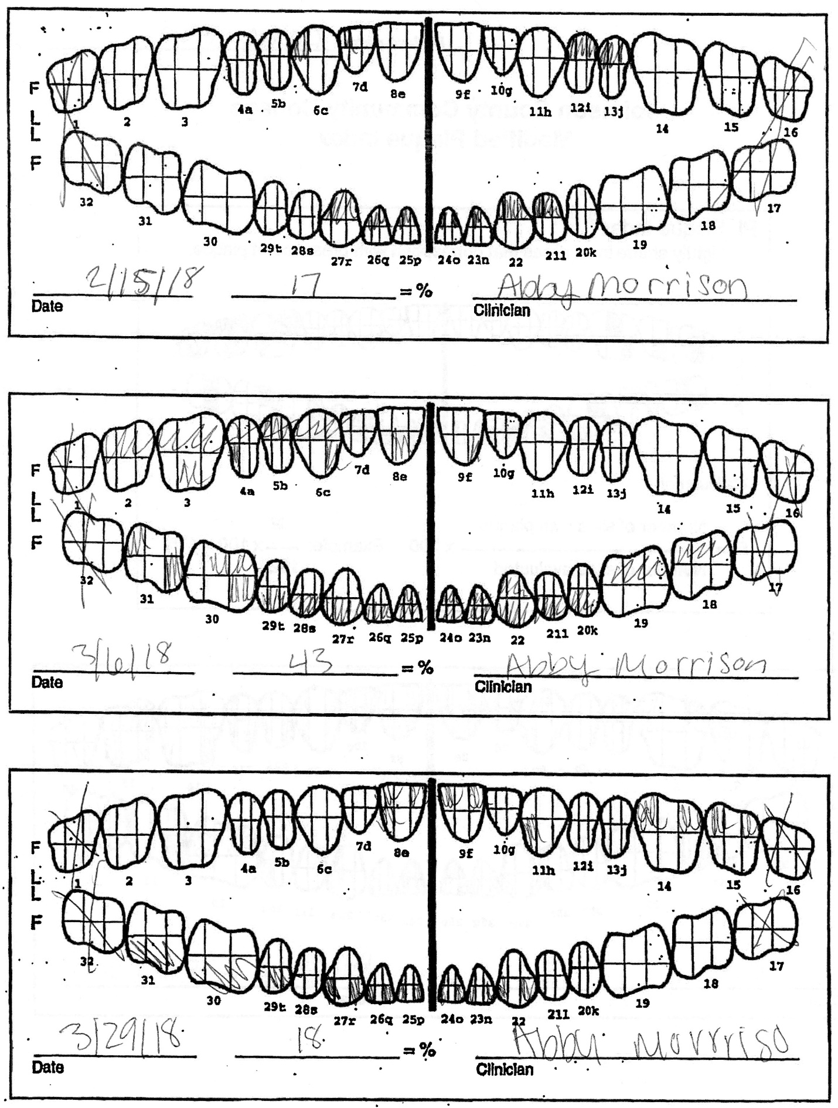
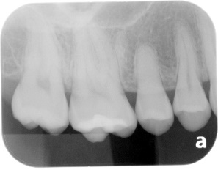
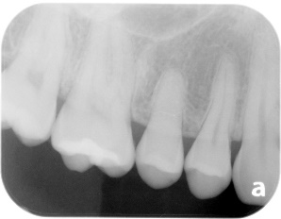
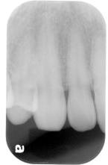
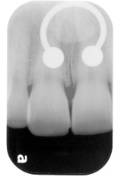
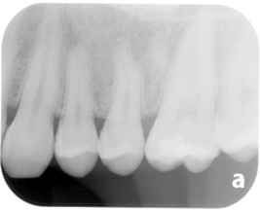
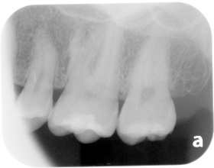
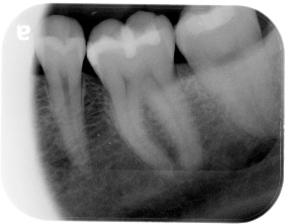
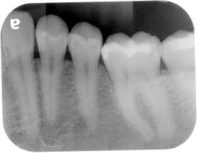
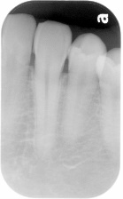
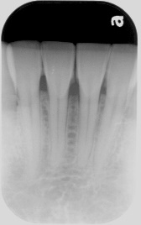
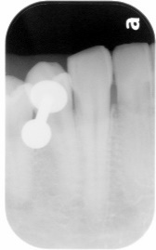
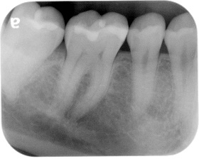
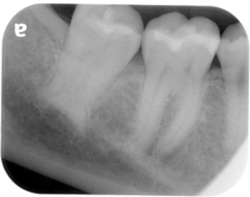
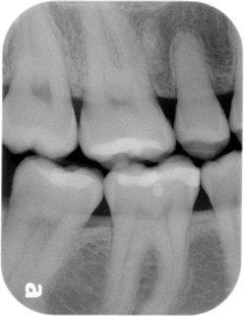
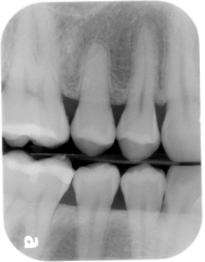
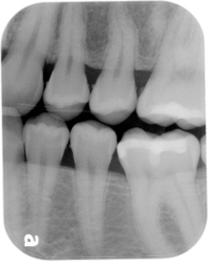
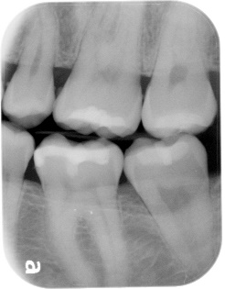
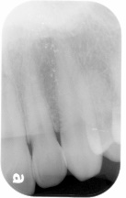
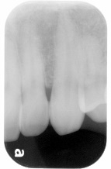
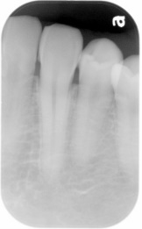
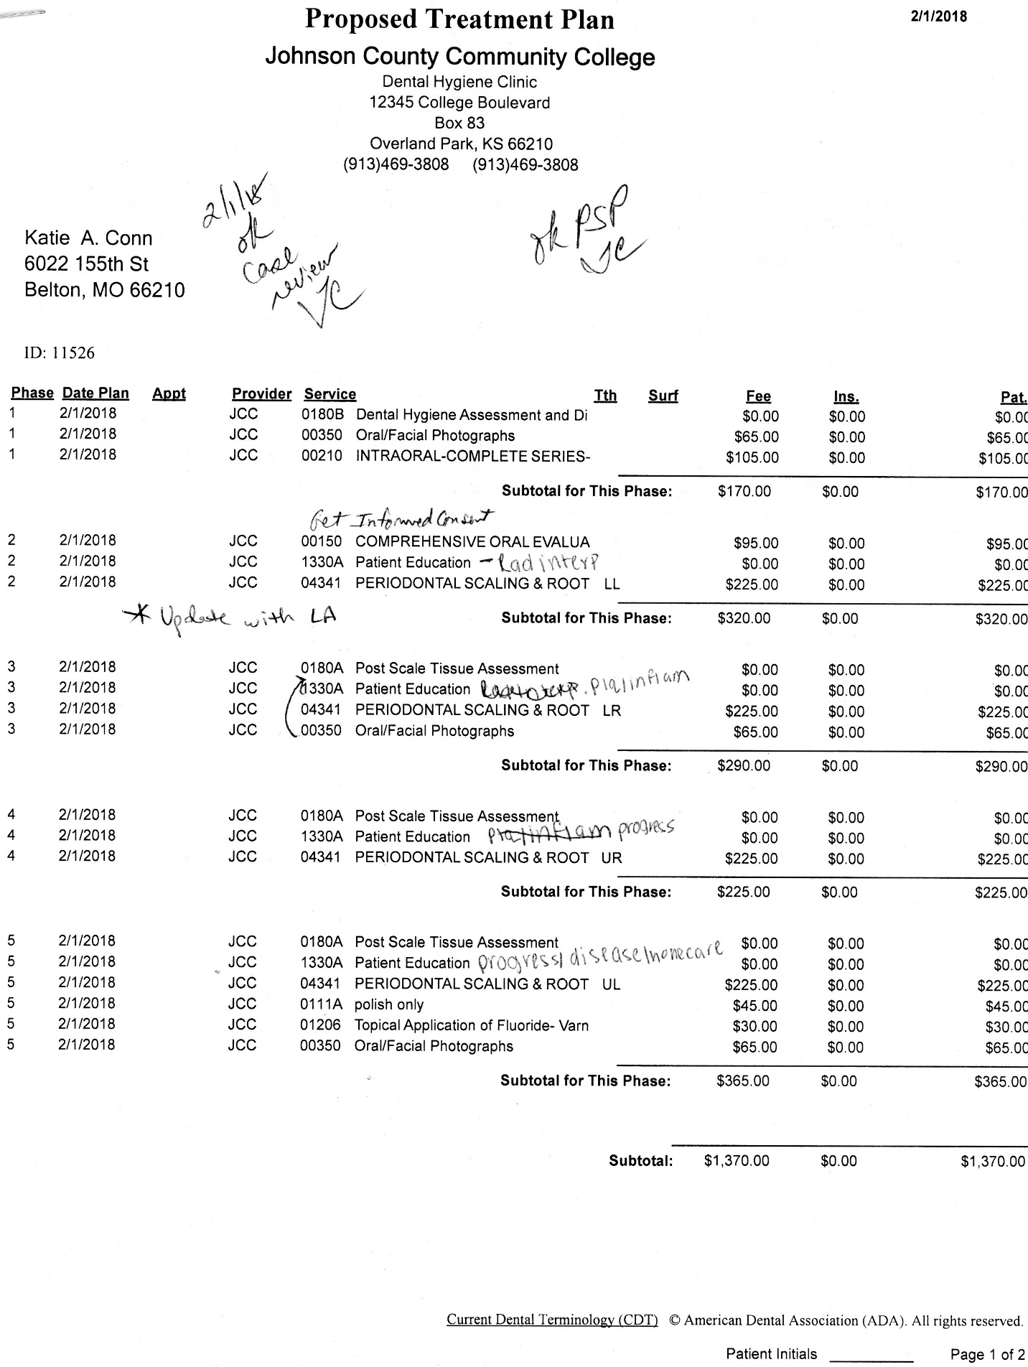

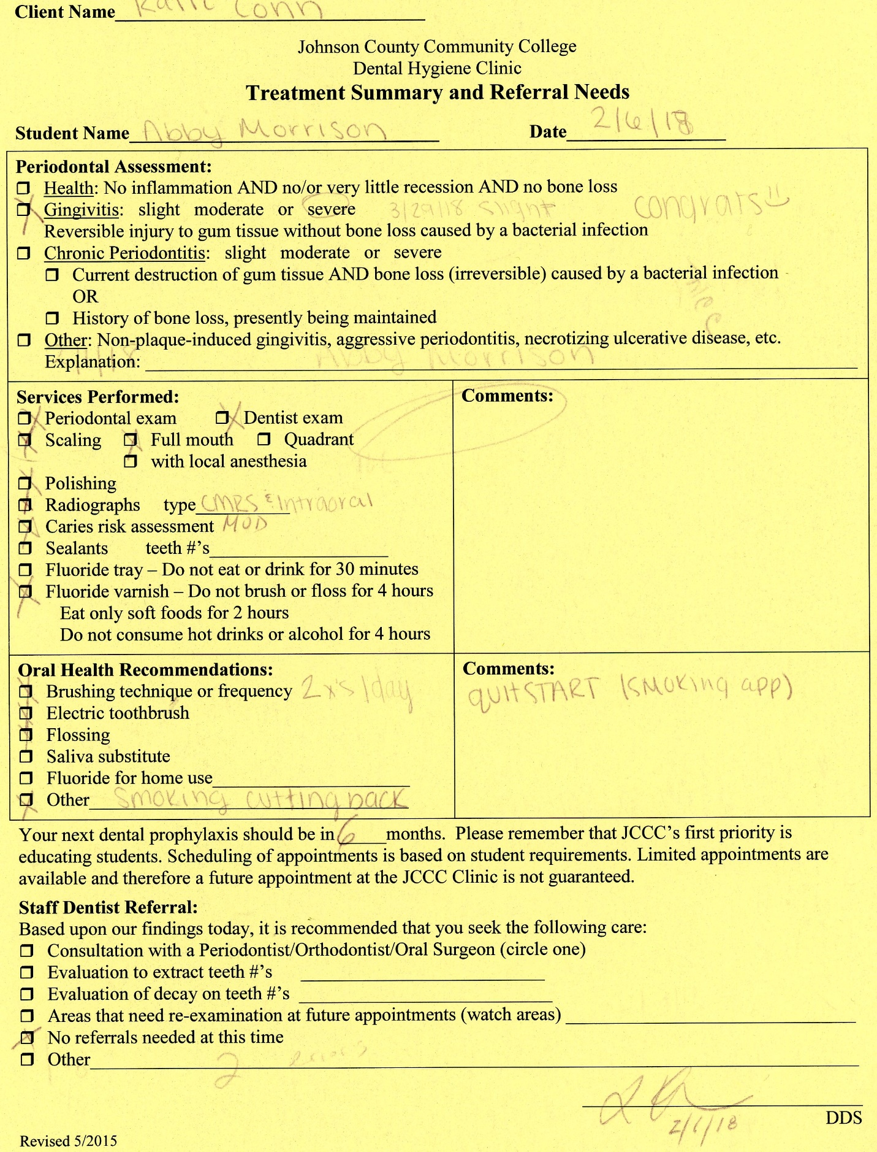

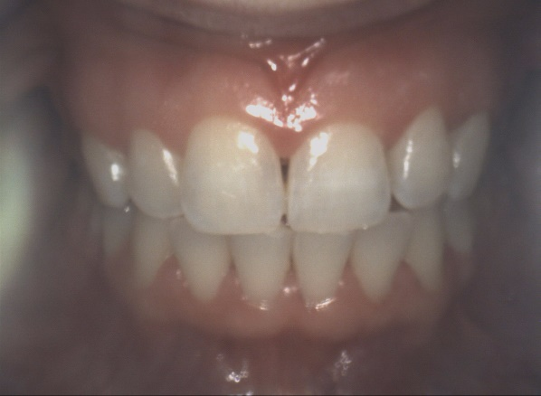
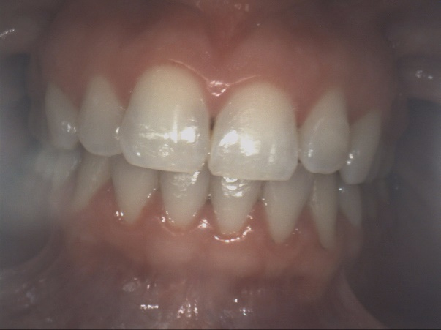

Full facial view AFTER
Full facial view BEFORE

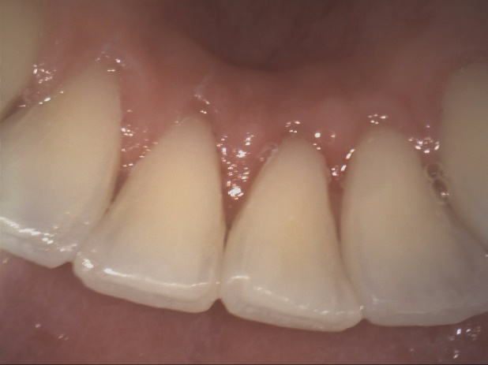
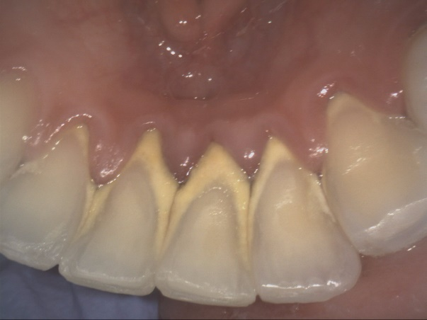
Mandibular anterior BEFORE
Mandibular anterior AFTER

