Amy Beth Blume
Personal Brand Plan, Development & Management

Throughout this course I have learned a lot of things, first of all I thought I was pretty tech savvy before this course and found out that I am not. When I first started this course my business BB Embroidery was only on Facebook, for a bit I also had a website but that was going nowhere fast. At one point we decided to change up the logo and try to get more followers to the page. When I started this class I had 93 followers on Facebook and ended the class with 106 followers. One thing that I am most proud of however is the fact that some of our posts reached over 200 views organically, no boosting posts or money spent to get those views. However as you can see by the original google search link from my blog post BB Embroidery is no longer attached to this search because I have changed the name to Blume & Co. Creations.
https://www.google.com/search?q=bbembroidery+kansas&rlz=1C1GCEA_enUS831US831&oq=bbembroidery+kansas&aqs=chrome..69i57j33.6962j0j7&sourceid=chrome&ie=UTF-8
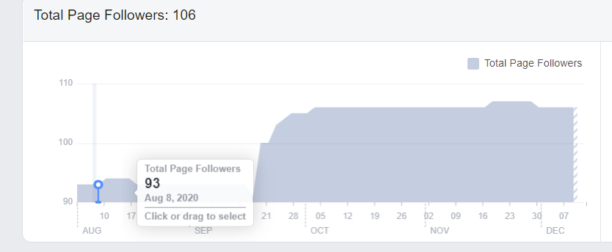
As you can see from the graph about on August 8 Facebook Insights shows my followers at 93 and the graph below at 106.
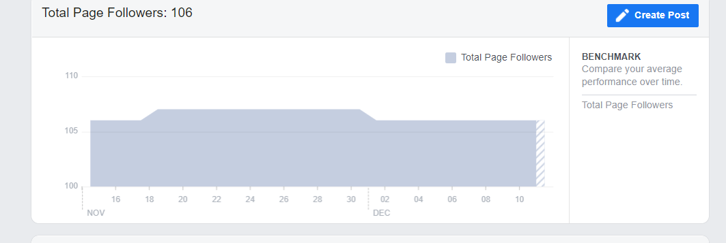
From the below list we see the posts with the most engagement within Facebook.
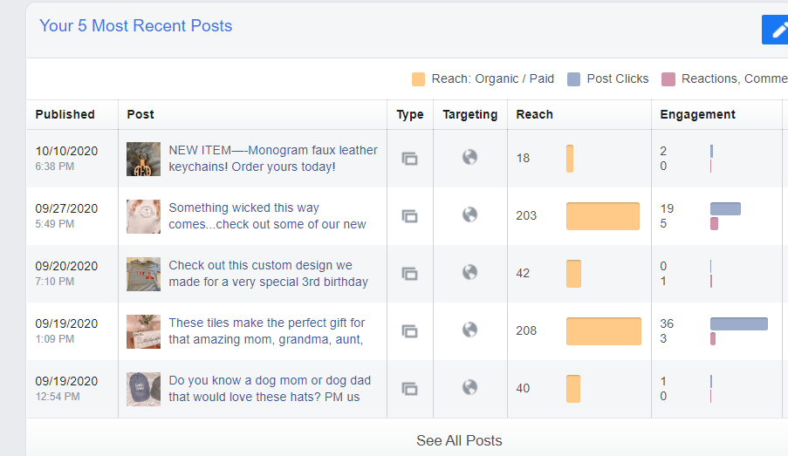

During this class I also started a business page on both Instagram and Twitter as well. Neither doing that great, but these weren’t platforms that I was comfortable with especially at first.
As you can see from the screen shot below my Instagram followers were only 9 at the end of the semester, however I started out with 0.
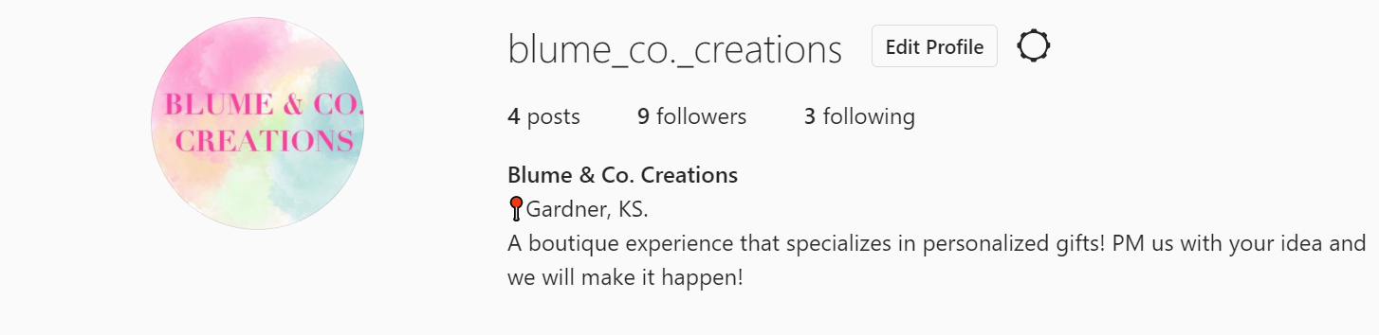
What I do find interesting is that the same post that reached 203 people from Facebook received the most likes out of my posts on Instagram.
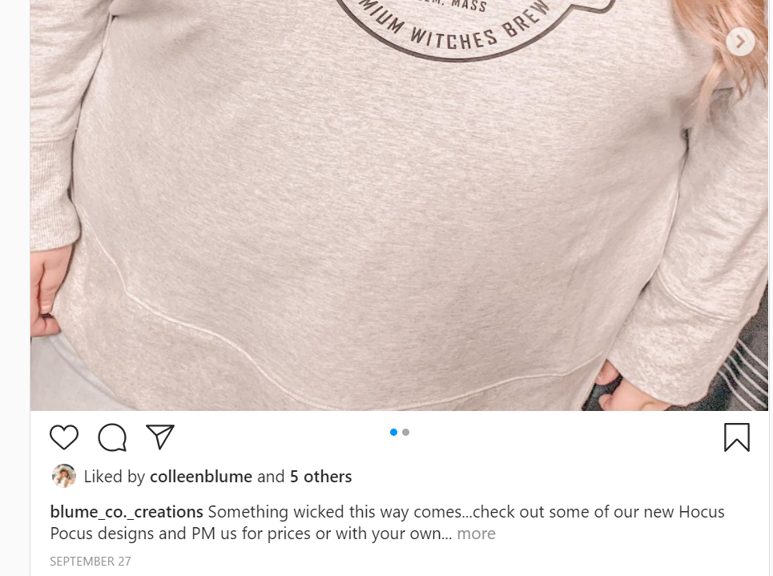

Unfortunately since I am still unsure of how to get on my Twitter on the computer I am not able to share any screen shots of that, but I did end up with 2 followers on Twitter (who might be my husband and one of my kids).
What I learned throughout this process is that it takes a lot to be a social media marketing person. It isn’t just throwing a post up and hoping it sticks, it is more the when to do it, how to do it, why to do it that needs to be thought about.
While I did have challenges through this course, I feel that it was mainly on the business side. I don’t give myself enough time to create new things and without constant posts you never get the attention that you are looking for. I think an opportunity for me would be to make a goal of at least once per week making a new item to put on the business pages to gain attention.
My strategy/game plan will be to utilize the continent calendar that we created in class and try to follow my thought process, making items for themes, having deadlines for sales and keeping up with posting.
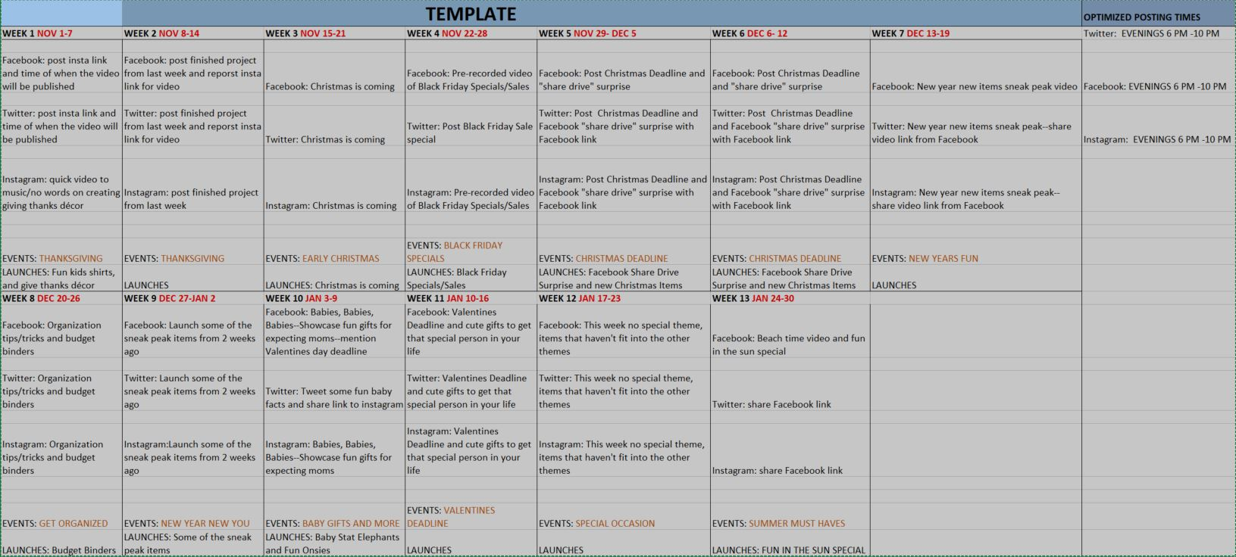
I feel that the people I really want to reach are the younger females, not teenagers but the millennials and up, these are the ages that I find most people would purchase something personalized and handmade.

