ONLINE PERSONAL
BRANDING PROJECT
MKT 146 | Social Media Marketing

Melissa McCloud
2019
During the semester, I have had the opportunity to work on developing my personal brand through social media. I have learned about many tools and strategies available to me in helping to optimize my social media accounts, therefore strengthening my personal brand. In my report, I will share with you a review and reflection of my brand as it has evolved throughout the semester.

Online Personal Brand Project

Facebook
First, I will begin by sharing my Facebook account with you. The image below, is a screenshot of my Facebook profile page from back in February when we first began working on our personal branding. At that time, I had 336 Friends.
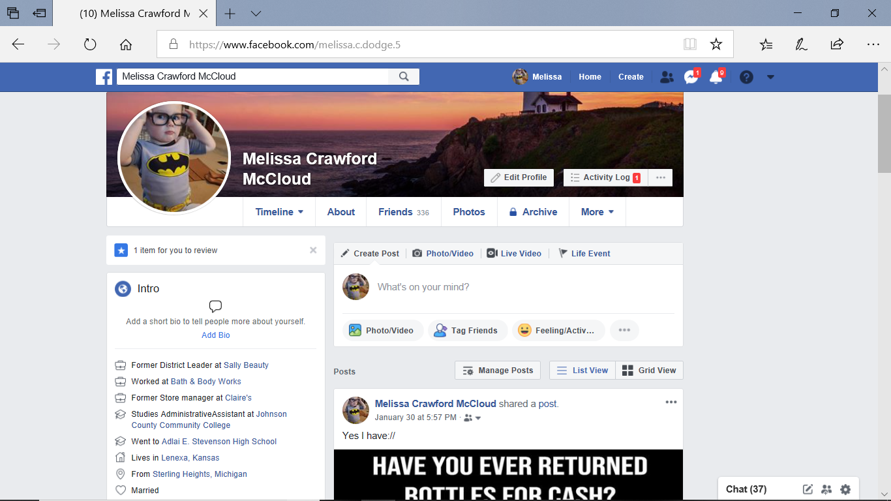

Facebook Changes
The changes that I made to optimize my Facebook were:

- changed profile picture to head shot of myself
- added Bio paragraph to profile
- added current job
- added pictures to media gallery
- changed some privacy settings

The image below shows my current Facebook page. As you can see, my Friends have grown to 388, which is 52 more than what I started with back in February.
https://www.facebook.com/public/Melissa-Mccloud
LinkedIn
When I first began with my personal branding, my LinkedIn account was set up, but not active. Because I was a student and not looking for employment, I didn’t see a reason to have an active account, so I never took the time to update my profile. Below, is a screenshot of where my LinkedIn page was when I began.
  - LinkedIn Changes
The following are a few changes I made to get my page ready to go live:
- updated pictures, wrote Bio, updated summary and organizations, and completed all sections of profile.
    - updated privacy settings
- connected with more people
- followed 5 hashtags

Making the above changes to my LinkedIn profile really helped to optimize my account. Within the last three months, my Connections have grown from 6 to 59. You can also see by my dashboard below, that I am seeing some activity. I have also had 4 professional inquires for employment within the past 2 months.

Your Dashboard

Private to you
All Star
28 Who viewed your profile 39 Post views 7 Search appearances
https://www.linkedin.com/in/melissa-mccloud-89b052147/

Twitter
About six years ago, I started a Twitter page so I could follow a new Christian artist, Colton Dixon. I didn’t do much with it to begin with, and after a short time, I lost interest in Twitter and stopped all activity. So when I started my personal branding, I pretty much had to start from the bottom creating my profile. At that time, I had 4 Followers and had 11 Followings (see image below).

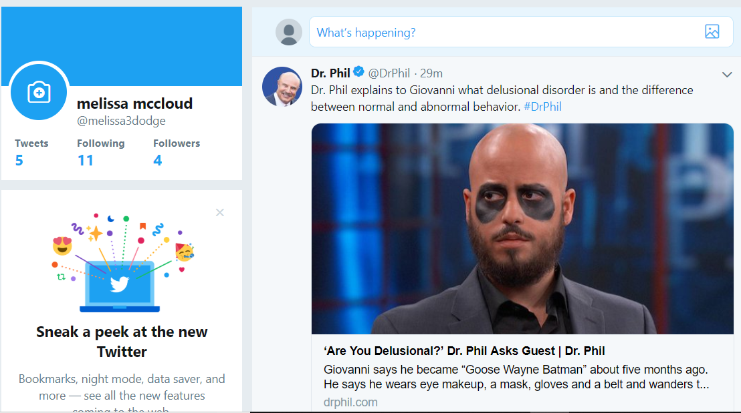

  - Twitter Changes
Similar to LinkedIn, I had to completely set up my profile so that I could really begin using it. My current Followers is now at 16 and my Followings are at 101. Below, are the changes that I made, and a screenshot of my updated Twitter page:

- redid Bio and changed pictures
- added followings
- changed privacy settings
- added hashtags
- made first Tweet
https://twitter.com/melissa3dodge?lang=en

What I Learned/Challenges/Opportunities
There is so much I’ve learned about social media throughout this semester of being in this class. Probably the biggest take-away for me is that keeping up with all the demands of your social media activity can be tedious and overwhelming at times. There are a lot of great tools to help keep everything organized, but you must be willing to take the time to learn them and then stick to using them. The biggest challenge I faced while working on my personal branding, was finding the time to devote to

keeping up with it. Because I wasn’t much of a social media person before this class, it wasn’t natural for me to be active on my accounts and I would often forgot that I needed to be. I know the opportunities are endless. I just need to put my time and effort into growing my branding with my active networks. There is still so much for me to learn and explore when it comes to really optimizing my accounts, which I know will only make my personal brand that much stronger.

My Game Plan Moving Forward
Although finding the time and putting the effort into my social media networks was a challenge for me this semester, I really plan to make a conscious effort to stick with it. Some of my plans moving forward are:
- Spend at least 15 minutes a day on one of my social media sites/alternate between sites each day.
- Continue to use Hootsuite to manage my Twitter, Facebook, and LinkedIn.
- Begin scheduling posts weekly.
- Once a month, choose a site to spend an hour on to reach out to new followings, friends, connections/ revamp profiles, pictures, etc.
- Take the time to get familiar with each site’s analytics/insights and do analytics checks every so often.
- Add my social media handles to my Business Cards.
- Conduct a Google Search on myself every three months to see how my personal brand is growing.

