This semester, my main focus was on my LinkedIn account. Mainly because that is the only one I want people other than family or friends to view. I did, however, work to make my Facebook, Instagram, and Twitter accounts more professional and unified if employers were to seek me out by changing my profile picture to something more professional. I use my Facebook and Instagram for personal use and I don’t really want to change that. I don’t have any business need to utilize these accounts in this way. The following lists the ways in which I use each accounts, what I’ve done to change each account to accomplish my goals for this semester, and what I have learned about each account if I were to have a business need for them.
Facebook/Instagram- Utilized to keep up with friends and family. All settings are set to private because I value my privacy when I am posting about personal things. I did not wish to change that at this point as there is no business need for it. I post frequently, whether it be a statues change or to add photos. I am very interactive on Facebook, from messaging friends to liking/commenting on friends and families posts. I plan to maintain my friends and family, adding as needed, but for non-business purposes. I did change my profile picture in hopes to unify my social media accounts if was to be sought out by employers they would see a professional picture. I linked Instagram on here because I very rarely use Instagram. I don’t post or even check Instagram as frequently as Facebook.
I learned how to track activity which is very important if you are using Facebook and Instagram for a business. I learned how to publish an Ad and track the success of it. I also learned how to track the success of a post. One important thing that I learned, was that you can censor certain words from appearing on your account. This is important when you are trying to uphold a certain image! I found this all very interesting and would be willing to take on a social media manager role if the opportunity were ever presented to me.
Twitter- Twitter is also one that I only don’t utilize for business need, but I also don’t use it to keep up with friends or family either. I like to “follow” certain celebrities and groups. I can see how Twitter could be a very useful tool for a business, to be honest, I didn’t really see how it could be before taking this class. I thought it was mainly for celebrities. My Twitter account has maintained this semester, however, I have gained a little more activity on this account. I am not sure how much more I am wanting to grow it at this point but I did want to change the profile picture as well.
The most exciting thing I learned this semester was about tracking progress. Twitter seems to have the best form of tracking! It also has a way to export this data right onto a spread sheet, which totally got my nerd side excited! I love spread sheets! I thought Twitters analytics were the easiest to follow and track.
LinkedIn- This is the one I really wanted to “beef up” as I do want to use it for business purpose. I changed my profile picture to something more professional and that was consistent to all my other social media accounts. I also added my current work experience and published on my page. I added a headline and made sure that it was the quality that I wanted other professionals to read, really making that 140 characters count. I plan to keep adding to this account and hopefully feel confident about adding the specific place that I would. Right now, I am not confident to make my presence in that aspect. As with the other accounts, I learned how to track progress of activity, see what generates traffic on my page, and how to make the most of the space I have. I am excited to continue to learn and build this account because, like I mentioned, I do want to utilize this for business only. This puts a new spin on what I want to learn and how I will grow this account and I am very excited for that!
Overview- I have learned how it is important to ensure you social media accounts align with business goals and culture that it is important to keep track of which types of post preform best on which social media accounts. My favorite thing was to create an Ad and learning how to incorporate that in social media. I also liked learning how to plan and execute a business strategy and the different roles involved in that process. I was very overwhelmed at the beginning of this semester. I thought I was pretty fluent on social media and that I would just pick up some tips, but what I learned was that social media marketing is a legit business need and takes skill, knowledge, and dedication. I can’t tell you how many times I thought about dropping the class. I went as far as searching for different classes I could possibly pick up instead. However, I am very glad that I didn’t do that. I learned so many valuable skills and I feel confident that I can offer these skills to a business! I wish I had known some of the things I know now at the beginning so I could really see the progress I have made, but I am proud of what I have!

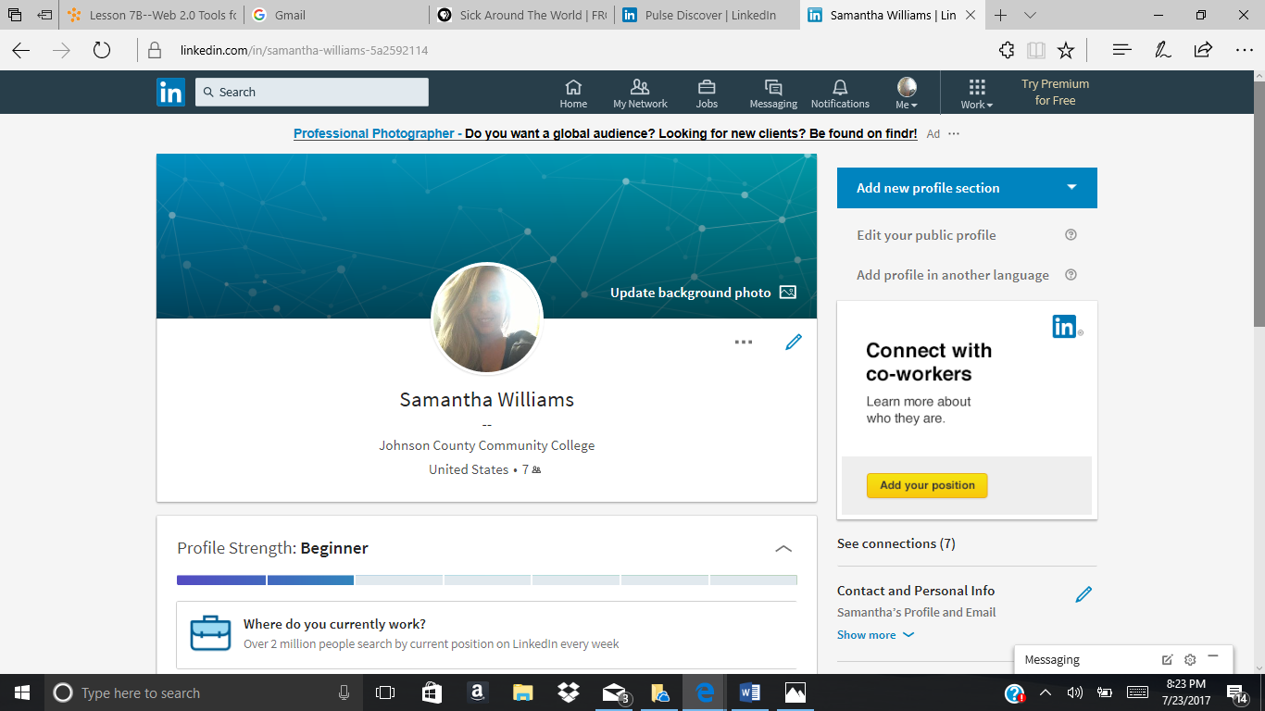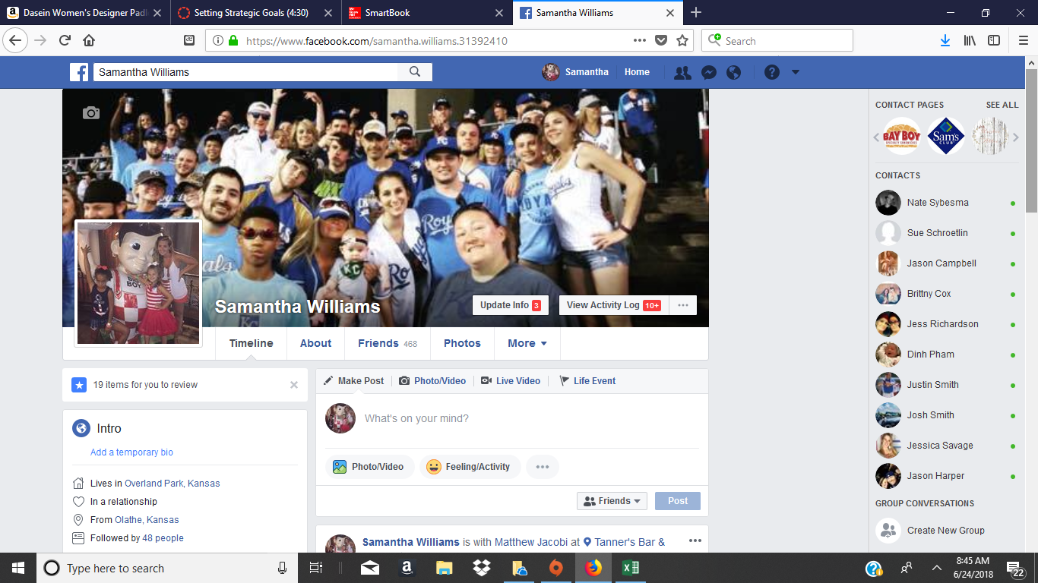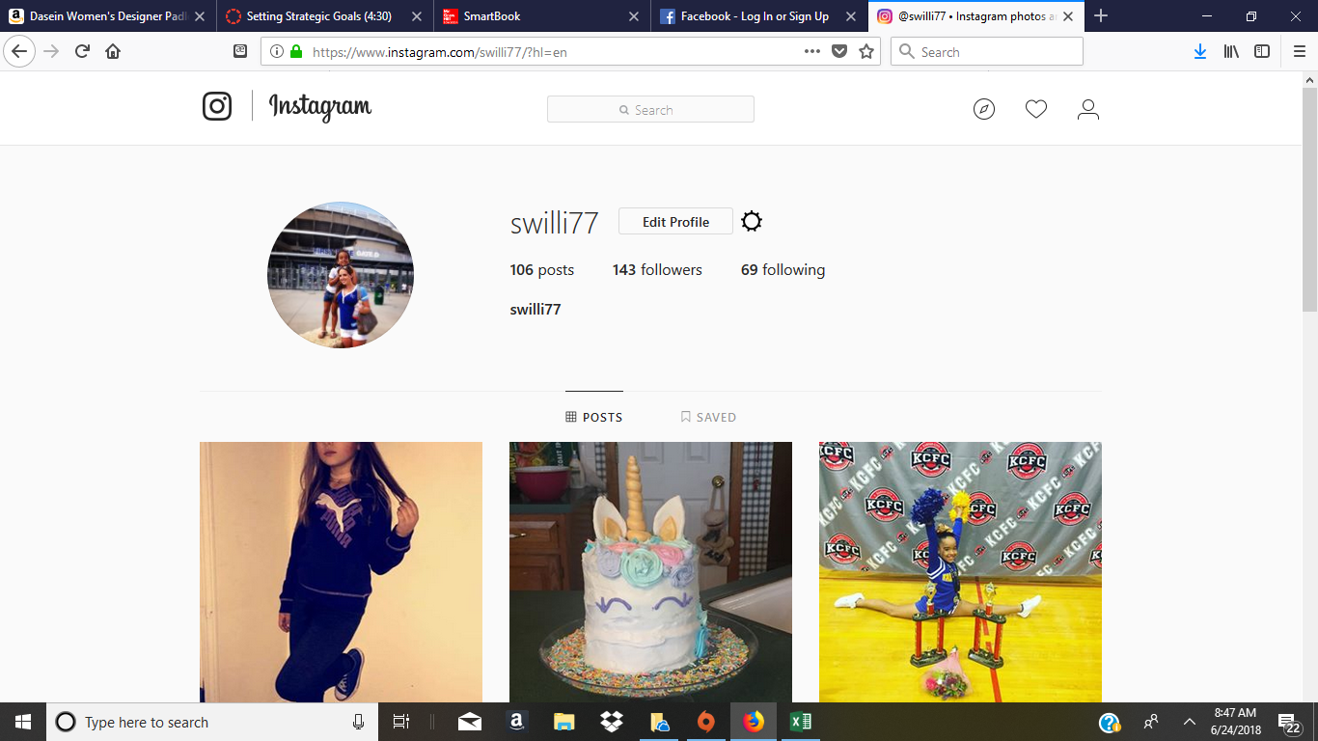
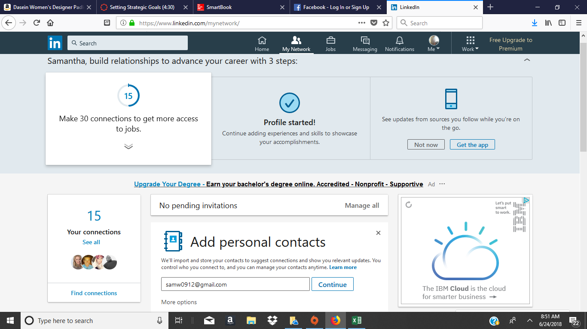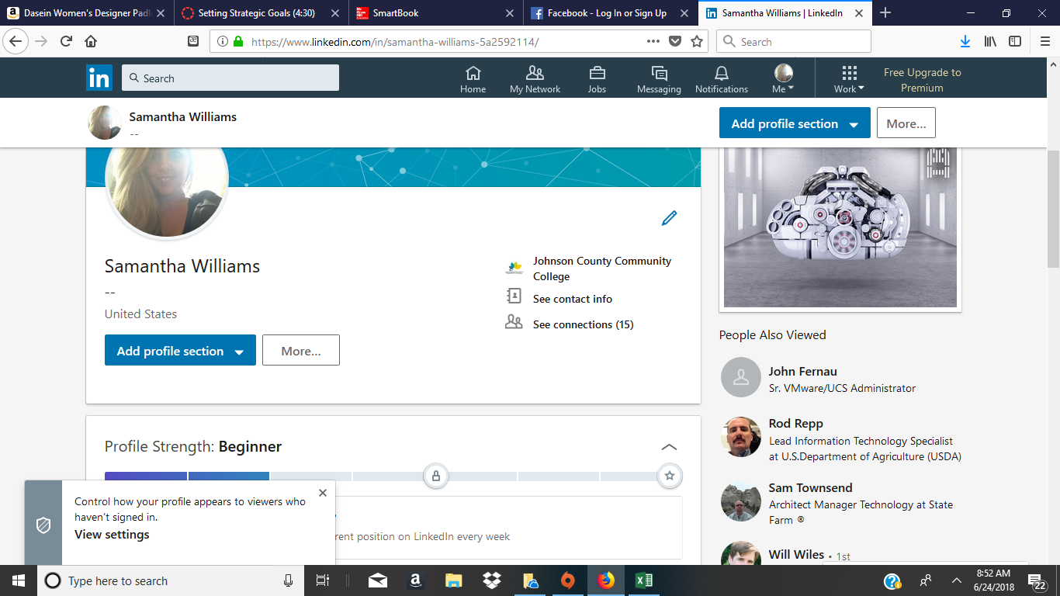
After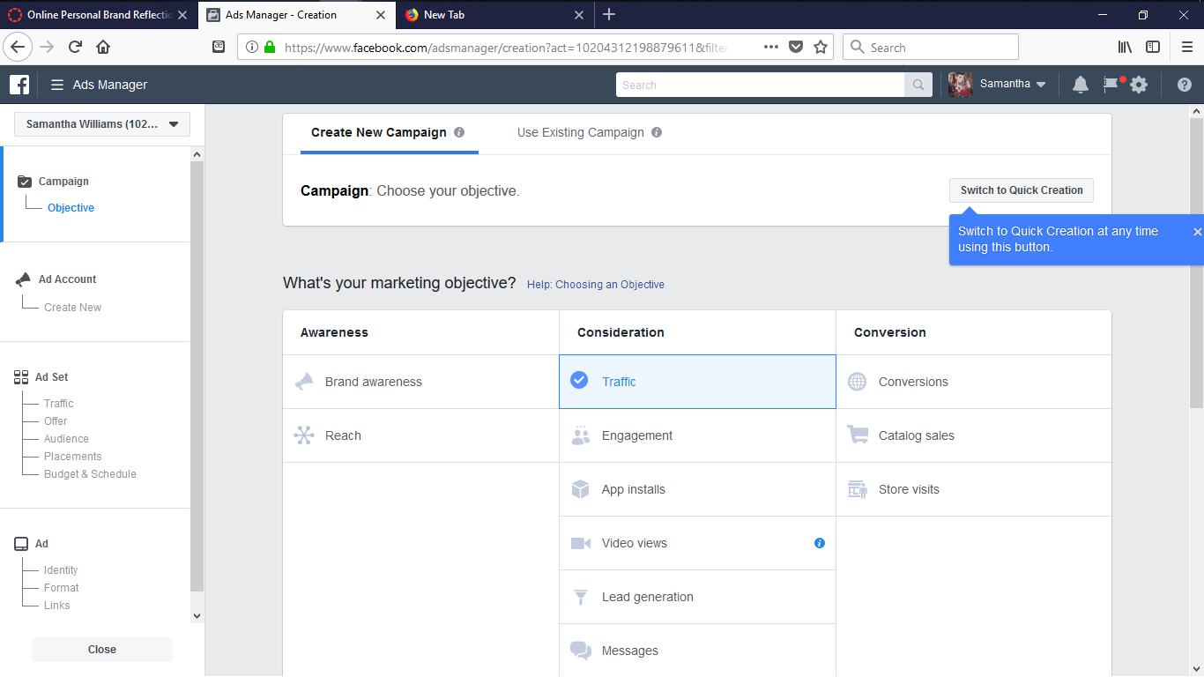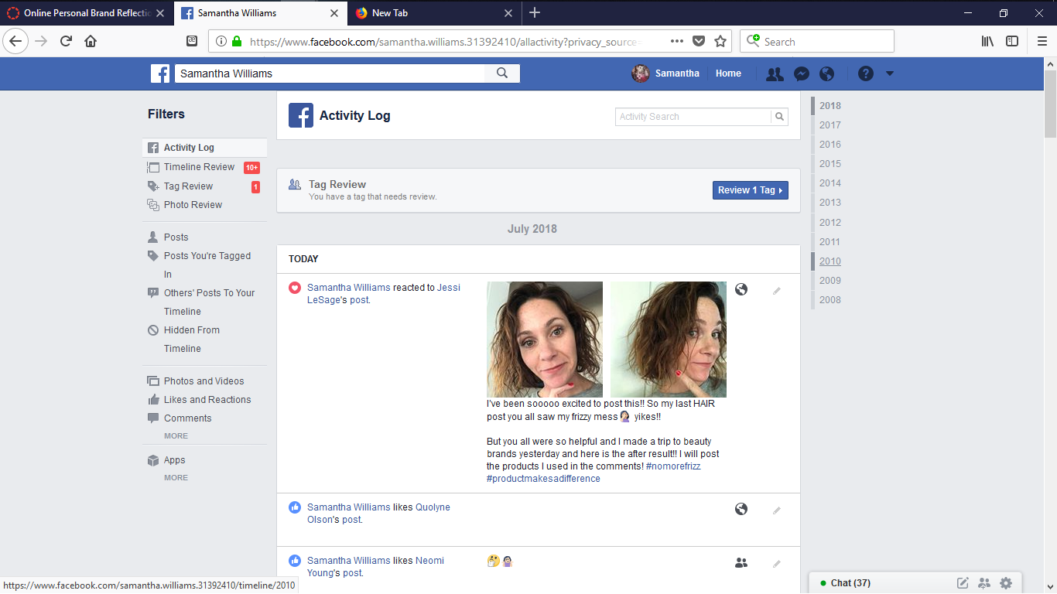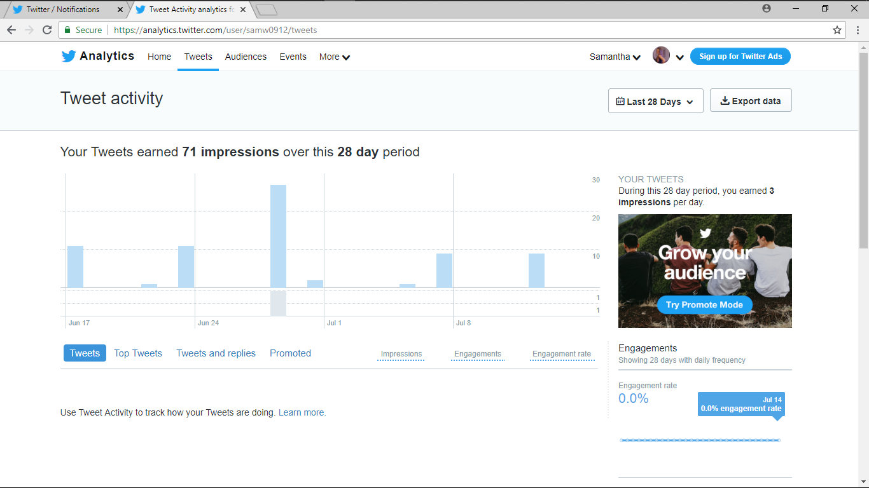
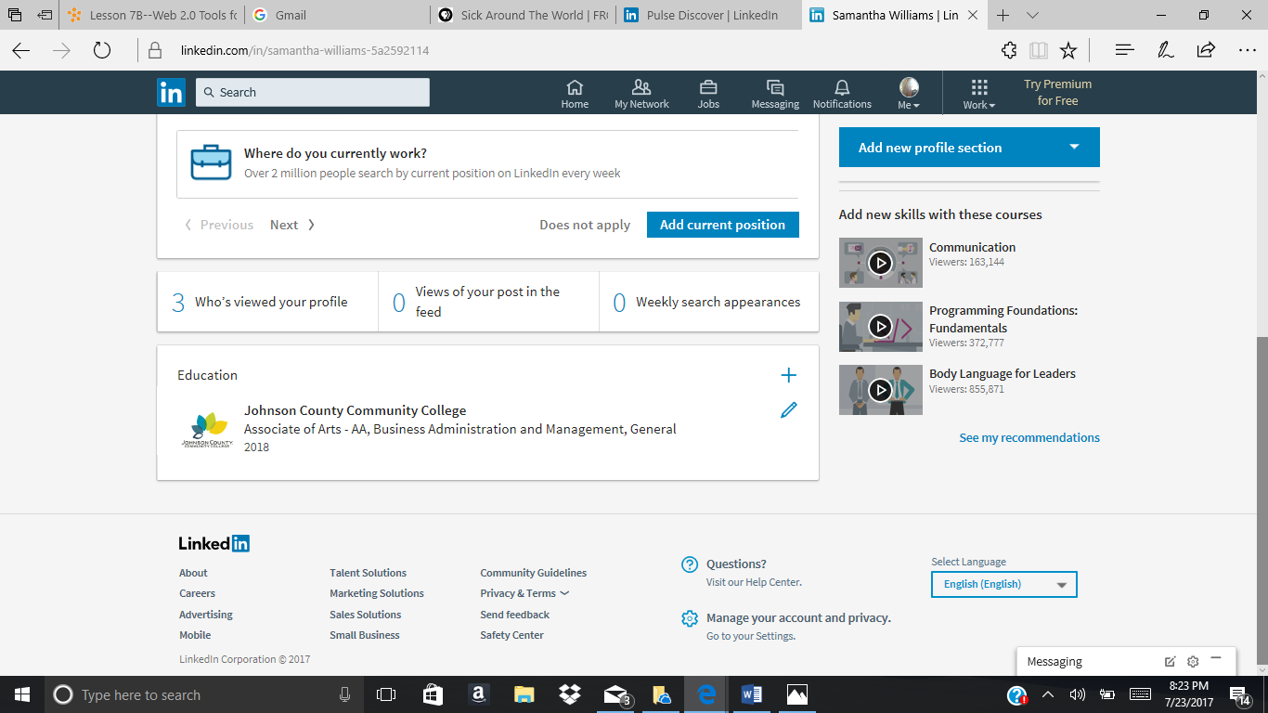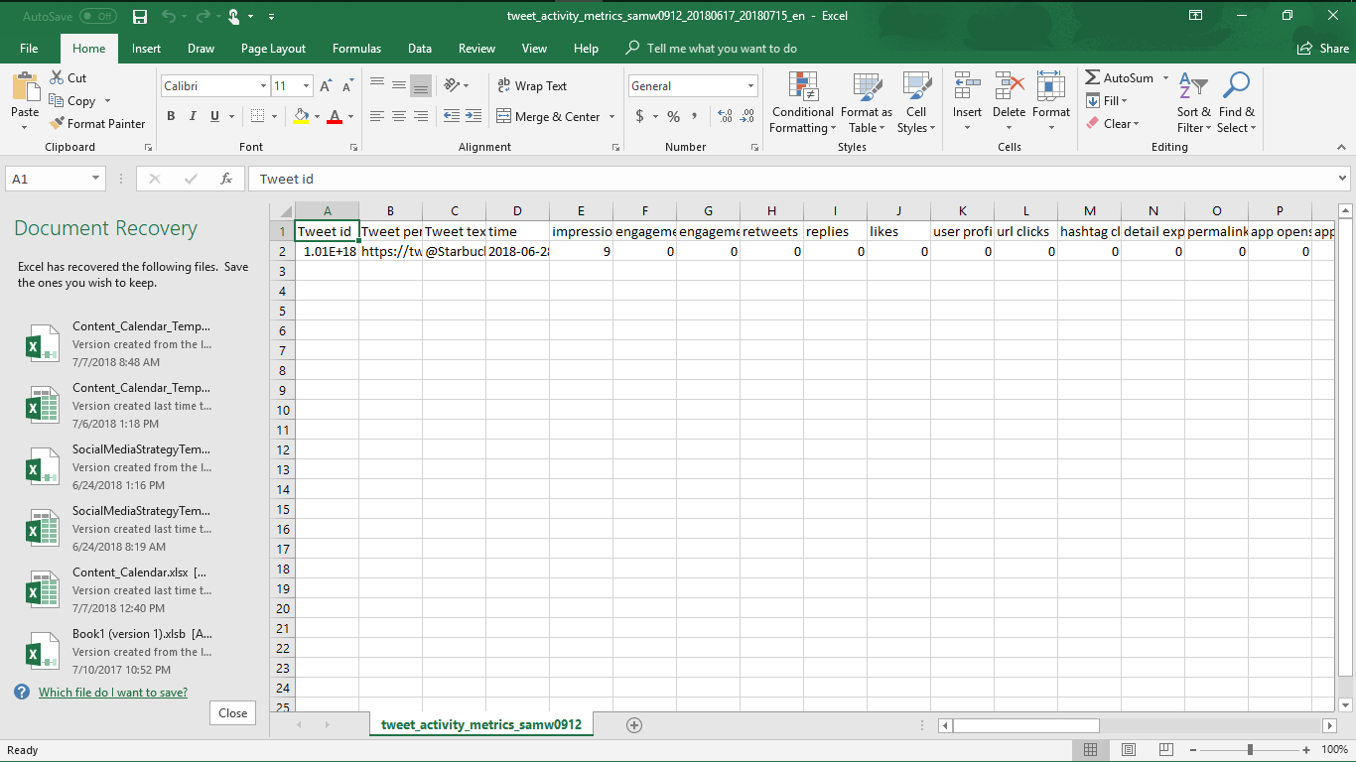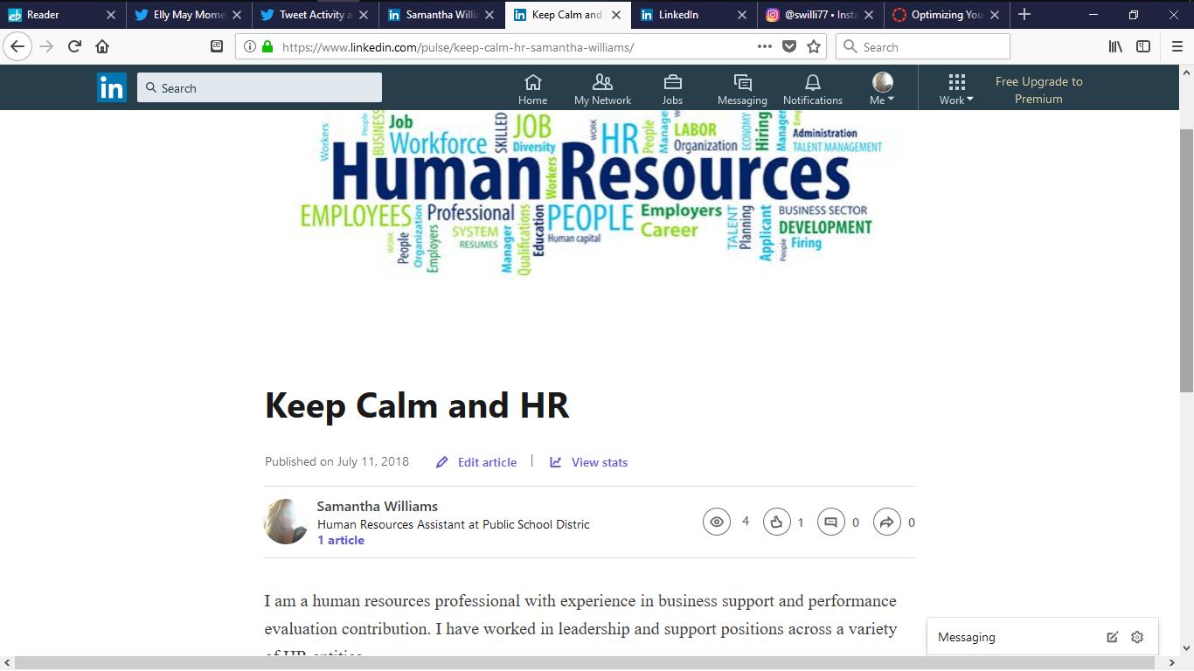
**NEW PROFILE PICTURE- Easier to see, more professional pose, better lighting.
